Report for WP1

Promoting academia-industry alliances for R&D through
collaborative and open innovation platform

Project reference number: 598719-EPP-1-2018-1-MK-EPPKA2-CBHE-JP

Project duration: 15 November 2018 – 14 November 2021
EU funding instrument: European Neighbourhood Instrument (Erasmus+: KA2 CBHE)
Erasmus+ (CBHE) grant amount: 531,165.00 €
Partner countries: Armenia, Bosnia and Herzegovina, North Macedonian, Austria, Germany, Finland
Target groups: University management and students, companies, research institutions, intermediaries.
Grant holder: Ss. Cyril and Methodius University in Skopje, North Macedonia
Coordinator: Prof. Elena Dumova-Jovanoska, Ss. Cyril and Methodius University in Skopje

This project has been funded with support from the European Commission. This document reflects the views only of the author, and the Commission cannot be held responsible for any use which may be made of the information contained therein.
This document is licensed under Creative Common
Attribution-NonCommercial-ShareAlike 4.0 International.

Document information
Workpackage | WP1 – Kick-off seminar and analysis of R&D&I potential
Workpackage leader | RUB
Due date | May 31, 2019
Revision | Version 1.0
Authors | Slavica Trajkovska, Angelina Taneva-Veshoska, Ana Tomikj
Editor | Elena Dumova-Jovanoska
Contributors | Ruediger Hoeffer, Vladimir Vitanov, Tauno Kekäle

DELIVERABLE REVIEW HISTORY

Version | Name, Partner | Status | Date | Summary of changes
1.0 | IECE | First version | 30.05.2019

Contents
Summary 4
1. Introduction 6
2. Key facts of partner and program countries involved in the project All4R&D 7
3. Assessment of the of the status quo of collaboration between universities and industry 10
3.1. Methodology of the ABC survey 10
3.2. Conclusions from previous analysis on ABC in B&H and Armenia 11
3.3. Results of the ABC survey 12
4. Self-assessment of R&D&I of partner institutions from Armenia and Bosnia and Herzegovina 41
4.1. Intellectual capital 43
4.2. Human capital 44
4.3. Structural capital 46
4.4. Relational capital 47
5. Collection of good practices in R&D and collaboration between academia and industry in program countries partner institutions 49
5.1. Good practices at UKIM 49
5.2. Good practices at IECE 51
5.3. Good practices at RUB 53
5.4. Good practices at UVA 54
6. Recommendation for strengthening of academia – industry cooperation 56
7. Annexes 60
7.1. Questionnaire for Academia Business Collaboration (ABC) 60
7.2. Survey results from self-assessment 66
7.3. Presentation on good practices UKIM 73
7.4. Presentation on good practices IECE 97
7.5. Presentation on good practices RUB 111
7.6. Presentation on good practices UVA 118

Summary

This report seeks to contribute to the understanding of the current situation on universities-industry collaboration, as well as the potential of the R&D&I potential of partner institutions from Armenia and Bosnia and Herzegovina (B&H). The report is structured in three main parts:
- Presentation and analysis of the survey results on academia-business collaboration (ABC);
- R&D&I potential of partner countries institutions based on their self-assessment;
- Good practices on academia-industry collaboration in N. Macedonia, Germany and Finland.

The challenge to manage university-industry collaborative and innovation projects is rooted in fundamental differences of partners’ logics. Universities’ openness contradicts with the protective attitude of companies and creates problems in regards to intellectual property rights. Another factor is conflicting objectives of collaboration and different time horizons, where industry is looking for tangible short-term outcomes and academia is interested in publishing.

Our motivation was the understanding that when companies and universities work in tandem they can push the frontiers of knowledge, and become a powerful engine for innovation and economic growth.

Introduction

Since their foundation, the role of universities in society has changed over time. Their first role was to preserve the culture and knowledge. Over time, the interaction with institutions outside universities has increased considerably. The linkages between universities and industry have changed in the form and in the intensity of the interaction. After the first role of the university – teaching, the second role evolved. But, nowadays new roles are also expected from universities – in terms of relationships and entrepreneurship. So, universities of today have to find the appropriate balance between teaching, research (basic and applied) and entrepreneurship.
Collaboration with universities allows companies to acquire new knowledge that can improve their organisational performance and competitiveness. Research projects, technology transfer, research consultancies are all different forms of university-industry collaboration. When university and industry collaborate in an innovation project, they create a collaborative unit that can be considered as one innovative enterprise with its own ‘strategic control’ and ‘organizational integration’ as some of the key social concepts.
Creating more strategic industry-university partnerships would substantially improve Europe’s climate for innovation. The agenda for the modernisation of Europe’s higher-education systems has made it a priority to strengthen the links between higher education, research and business to drive innovation. The EU programmes on education (Erasmus +) and R&I (Horizon 2020) will ensure that such interactions are fostered and fully exploited. The Commission already has launched a number of initiatives to enhance closer and more effective ties between the three corners of the knowledge triangle, including the European Institute for Innovation and Technology (EIT), the Knowledge Alliances and the University-Business Forum.
But, even though very appealing and promising, for most universities – even those with cutting-edge research – partnering with industry does not come naturally.
The excellence of the All4R&D project is to develop and apply unique approach of establishing specific, wide-ranged, interactive and comprehensive connection between academia and industry. The project aim is to accelerate research, innovation, knowledge and technology transfer in Bosnia and Herzegovina and Armenia through enhancing strategic academia-industry alliances. More specifically several objectives are set:
- Reinforce existing and establish new university structures (R&D Units);
- Establish a web based platform for collaboration;
- Review the collaboration methods through pilot projects;
- Enhance career development and employability by innovative research and education opportunities.
The first work package (WP1) Kick-off seminar and analysis of R&D&I potential is very important for good start of project activities, because serves as support and good basis on the following project activities. Universities and companies from Armenia and B&H reflected on current practices and conducted self-assessment of their R&D&I potential. Partners from program countries presented their experiences and good practices in academia-industry collaboration. In order to better understand the results and following presentations, it is useful to have in mind relevant information on the countries on macro level and their ranking on global scale in regards to investments in research and innovation results.

Key facts of partner and program countries involved in the project All4R&D

According to the GDP per capita, the program countries Germany and Finland are categorised as developed countries, while the program country Republic of North Macedonia and the partner countries Bosnia and Herzegovina and Armenia are categorised as developing countries.
Table 1: Key facts of partner and program countries involved in the project All4R&D
Indicators | Germany | Finland | North Macedonia | Bosnia and Herzegovina | Armenia
GDP per capita (2017), World Bank in USD | 44,469.91 | 45,703.33 | 5,442.61 | 5,180.64 | 3,936.80
Global Innovation index | 58.00 | 59.60 | 29.90 | 31.10 | 32.80
Ranking according to Global Innovation index | 9 | 7 | 84 | 77 | 68
R&D spending as % of GDP, Unesco | 2.9% | 3.2% | 0.5% | 0.3% | 0.2%

The Global Innovation Index (GII) provides detailed metrics about the innovation performance of 126 countries which represent 90.8% of the world’s population and 96.3% of global GDP. Its 80 indicators explore a broad vision of innovation, including political environment, education, infrastructure and business sophistication. According to this index, Germany and Finland are in the top 10 Global Innovators, while Bosna and Herzegovina, Armenia and N. Macedonia are far behind.
The global spending on R&D has reached a record high of almost US$ 1.7 trillion. About 10 countries account for 80% of spending. As part of the Sustainable Development Goals (SDGs), countries have pledged to substantially increase public and private R&D spending as well as the number of researchers by 2030.
The innovation performance of the construction industry has been the focus of significant attention by industry practitioners, government analysts and policy makers, and researchers across the globe. The answer to the industry’s continuing problems is said to lie in building a stronger innovation culture to improve the rate and quality of innovation across the construction system, particularly given increasing client demands for integrated services. Nevertheless, construction continues to underperform significantly compared to other industries in terms of innovation activity. In addition to those broader industry challenges already highlighted, a history of limited investment in R&D and new technologies needs to be addressed to raise the overall capacity for R&D and its adoption in this industry.

Assessment of the of the status quo of collaboration between universities and industry

Methodology of the ABC survey

This project is oriented toward bridging university and industry and overcoming the challenges. One challenge is creating university-industry collaboration strategies and objectives. We answered the following questions: ‘How to define project objectives and strategy for university-industry collaboration in innovation projects so collaboration will continually boost the knowledge base of both partners in a long-term perspective?’ Second challenge is facilitating university-industry innovation projects. The question was: ‘How to facilitate projects to enable knowledge creation and innovation?’
It is proven that structural conditions, formal and informal incentive systems, norms for internal and external collaboration are crucial for learning and innovation processes. Different forms of collaboration between university and industry require different support structures and motivation mechanisms. The challenges that surface include a lack of trust over issues such as intellectual property, uncertainty about the potential benefits of working together, and the difficulty on both sides of finding the time for initial exploratory conversations. Having this in mind we developed the methodology and the ABC questionnaire.
The ABC questionnaire is conducted in the early stages of the project to assess the current situations in the partner and program countries to analyze ABC potential. The questionnaire was sent to universities and companies to collect information about:
- Current ABC activities and types of collaborative projects
- Factors that promote and motivate ABC
- Factors that inhibit ABC or are obstacles for ABC
- Existing support mechanism/structures for ABC in the respective organization
- Importance of possible outcomes of ABC
The ABC questionnaire was distributed in four different languages – English, Macedonian, Bosnian and Armenian. The questionnaire comprised 8 related ABC questions, rating from none (1) to exceptional high (5) or Yes/No questions. Additionally, there were 12 questions, related to the respondent.
Data was collected by means of an online survey sent out via email to relevant stakeholders, using the contacts and database of each partner organization. The link for the survey was also publicly available, and presented on the E1 in Yerevan and Sarajevo, leading to a total of 209 responses from program and partner countries.
In this survey research questions were asked to understand what are the differences between academia and industry, their positions and perception on ABC experiences. We also wanted to find out what are the main differences, and also what did this mean for the analysis of the answers from program/partner countries?
The results provided positive signs of the current situation and indications to the areas and aspects of the ABC that require special attention and future development.

Conclusions from previous analysis on ABC in B&H and Armenia

On this topic analysis were conducted in both, B&H and Armenia. In short, the conclusions state:
- Research results show that in Armenia, the poor linkages between education and industry are notably critical as well as the existence of innovative intermediaries and support institutions. The government is not a full-fledged facilitator and has an interventionist function in business. The analysis of Armenia case showed that there is no common practice encouraging university-industry collaboration.
- In the Researchers report for B&H it was concluded that in B&H, the involvement of the industry sector accounts only for providing financial resources towards the practical application of the R&D results. Similar to Armenia, in B&H the government have not promoted any concrete measures encouraging researchers to move from the public to the business sector and vice-versa.
On the other hand, if we analyse the Strategies and policies for research and innovation, different perspectives are shown:
- Strategic goal of the Strategy of scientific and technological development in B&H focuses on strengthening collaboration between academia and industry is: Strengthening cooperation and the transfer of research results from academia to the economic sector, support to technology transfer and strengthening the innovation capacity of enterprises.
- Strategy on Development of Science for 2011-2020 in Armenia, its vision: By 2020 Armenia is a country with knowledge-based economy and competitive within the European research area with its level of basic and applied researches. Armenian government is making an effort to encourage science–industry linkages, even though still the supply of knowledge-intensive business services is weak.

Results of the ABC survey

On the following pages the results from the ABC survey are presented. In the survey 209 participants participated (exceeding the minimum requirements of 200). Respondents (only assignable answers) are:
• from all participating countries;
• program countries 57 validated responses;
• partner countries 142 validated responses;
• 78 validated responses from universities;
• with different levels of education (BSc, MSc, PhD);
• 117 validated responses from industry; and
• From <10 to 1000+ employees.

- On the question in which ABC activities do you participate, the respondents from partner countries answered from exceptionally high and none for the following types of activities:

Exceptionally high
Curriculum co-development, co-design and co-delivery
Mobility of professionals
Mobility of students
Lifelong learning programmes for people from business

None
Shared resources
Governance
Joint R&D (incl. joint funded research)
Comercialisation of R&D results
Spin offs

Partner countries engage with business mainly in Curriculum co-development, co-design and co-delivery and mobility of professionals and students. However, around 30% of them do not engage in these activities at all. Overall, the development of ABC management and valorisation activities is lower than the Education and Research activities.

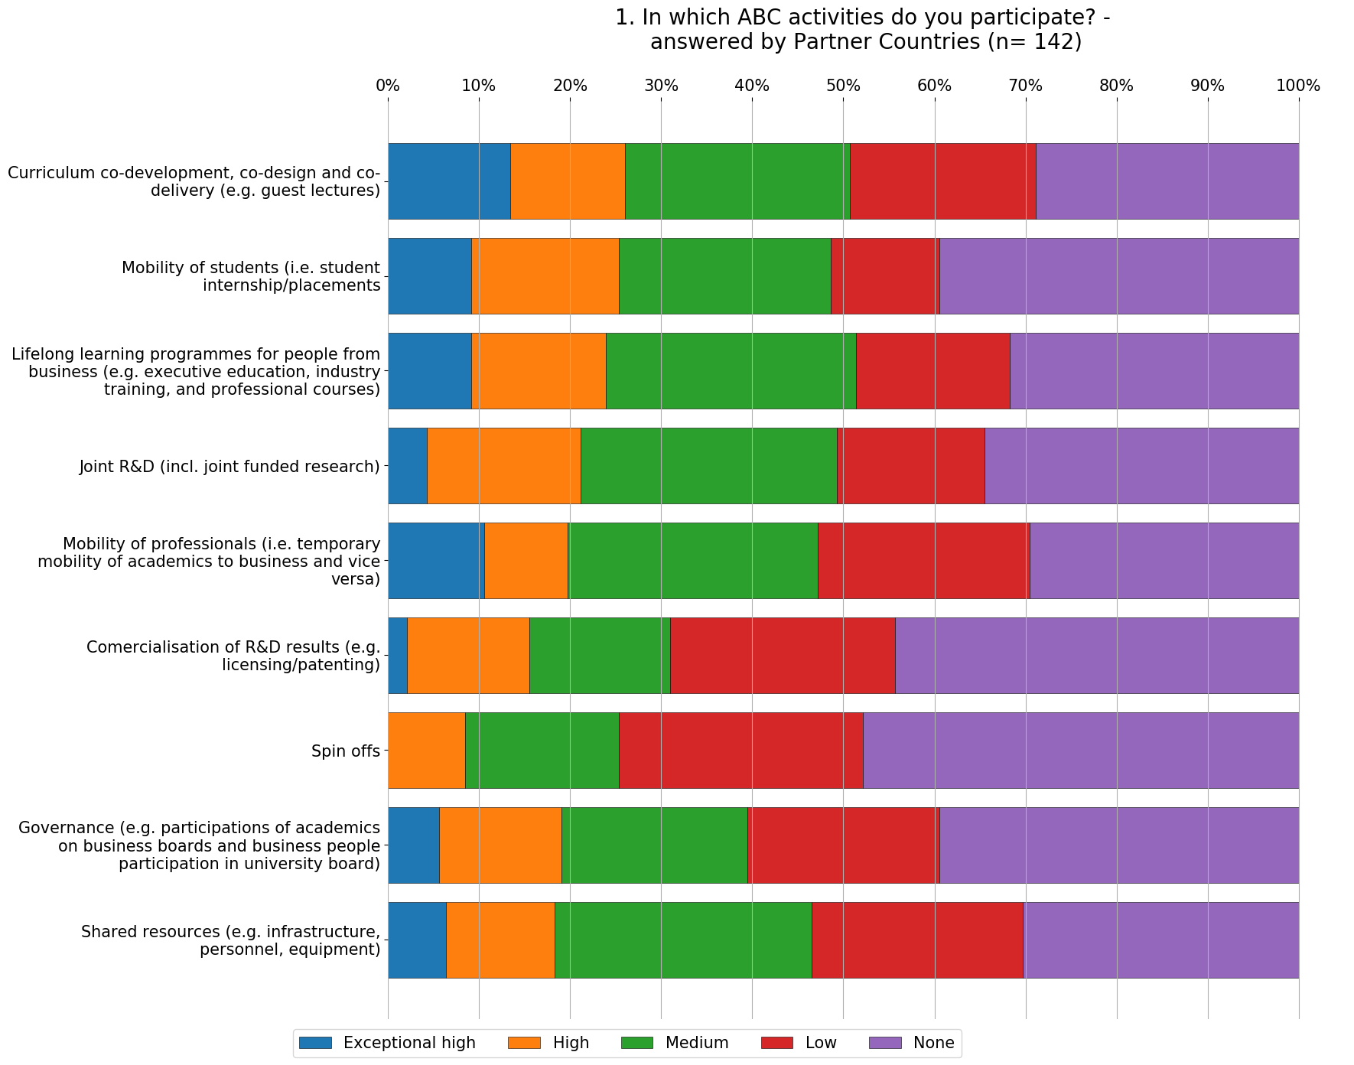
- On the question in which ABC activities do you participate, the respondents from Industry answered from exceptionally high and none for the following types of activities:

Exceptionally high
Lifelong learning programmes for people from business
Mobility of professionals
Mobility of students
Governance

None
Curriculum co-development, co-design and co-delivery
Shared resources
Joint R&D (incl. joint funded research)
Comercialisation of R&D results
Spin offs

The Industry engages with academia mainly in Lifelong learning programmes for people from business, Mobility of professionals and students. Nevertheless, around 30% of them do not engage in these activities at all. In general, valorisation activities are the least developed part of the Academia-business collaboration.

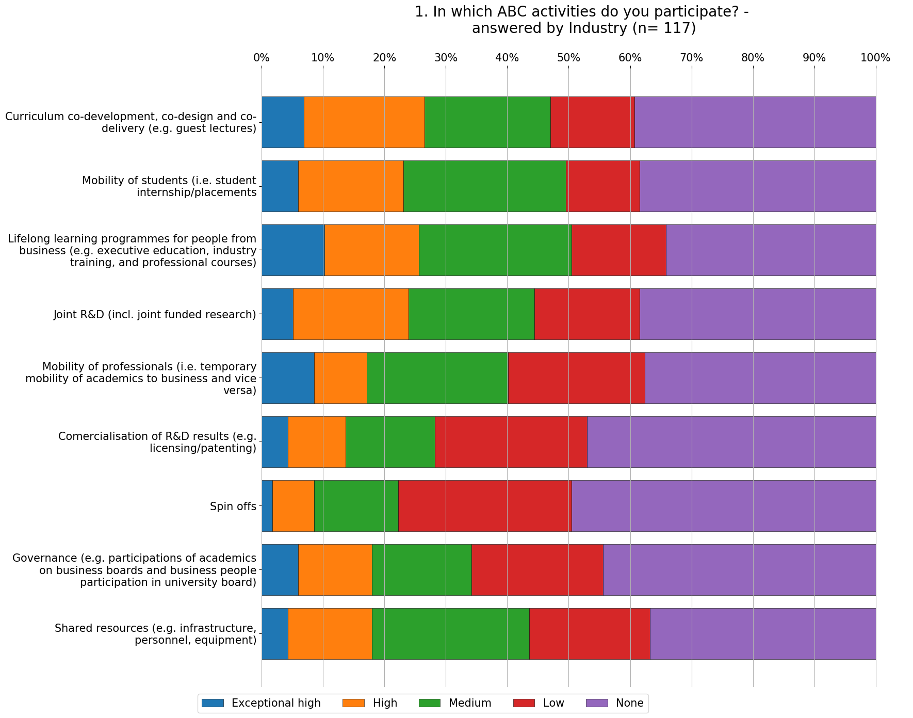

- On the question in which ABC activities do you participate, the respondents from Univeristy answered from exceptionally high and none for the following types of activities:
Exceptionally high
Curriculum co-development, co-design and co-delivery
Mobility of students
Joint R&D (incl. joint funded research)
Mobility of professionals

Governance

None
Shared resources
Lifelong learning programmes for people from business
Governance
Comercialisation of R&D results
Spin offs

The Universities engages with industry mainly in Curriculum co-development, co-design and co-delivery, Mobility of students and Joint R&D (incl. joint funded research). It is interesting to point out that Lifelong learning programmes for people from business were the highest ranked by the industry, while the Universities ranked them much lower – more than 30% said they have no cooperation and only 5% responded with Exceptionally high. Overall, as with academia the valorisation activities are the least developed part of the Academia-business collaboration.

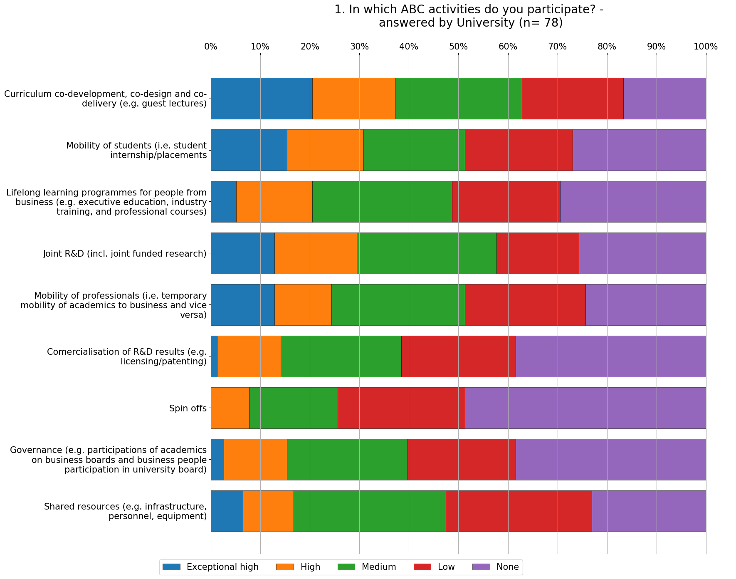

- On the question what types of collaborative projects have you been involved in, the respondents from Industry answered from yes and no for the following types of activities:

Exceptionally high
Educational project
Problem solving
Joint research projects
Knowledge generation
University Consulting

None
Student undertaking industrial training
Technology development
Idea testing
PhD or Master research
Joint publications

In general, there is no big discrepancy between the different types of collaborative projects among Industry, where the highest positive answer was Educational projects with 61% of the respondents and lowest answer was Joint publications with 41% of the respondent answering positive.

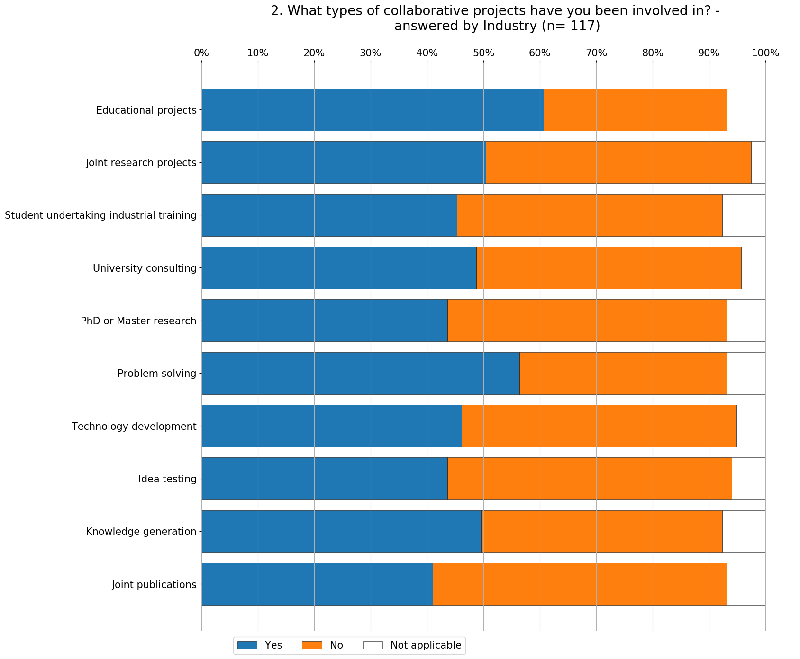

- On the question what types of collaborative projects have you been involved in, the respondents from University answered from yes and no for the following types of activities:

Exceptionally high
Educational project
Problem solving
PhD or Master research
Joint research projects
University Consulting

None
Knowledge generation
Joint publications
Student undertaking industrial training
Technology development
Idea testing

Overall, there is a bigger discrepancy between the different types of collaborative projects among University compared to the answers given from representatives from Industry, where the highest positive answer is Educational projects with 73% of the respondents and lowest answer was Idea testing with 36% of the respondent answering positive.

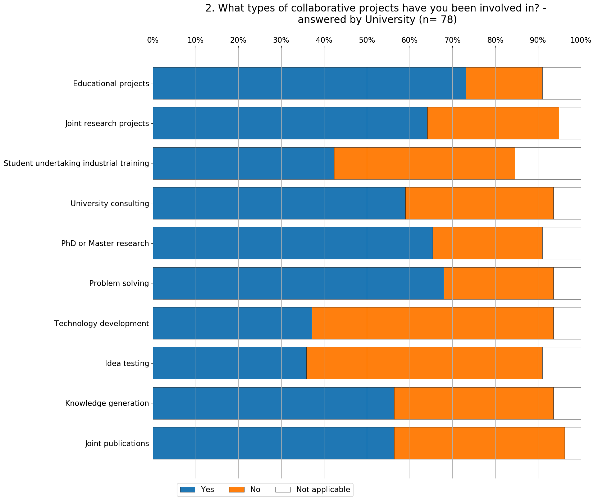
- On the question Assess each of the following factors that are facilitating your ABC, the respondents from Industry and Universities answered from exceptionally high and none

Facilitating factors encourage academia and businesses to engage in ABC. The main factors that facilitate ABC for both Industry and University representatives are very similar.
For the Industry the existence of a funding to undertake the cooperation is the most crucial factor, whereas University representatives perceive the interest of the Prior relation with the partner as the main facilitator. The main drivers facilitating ABC focus on the funding and prior relationship aspect, highlighting the importance of mutual trust for successful ABC.

Industry | Universities
Existence of funding to undertake the cooperation | Prior relation with the university partner
Existence of mutual commitment | Existence of funding to undertake the cooperation
Prior relation with the university partner | Existing of mutual trust
Existing of mutual trust | Existence of mutual commitment
Existence of shared goal | Existence of shared goal

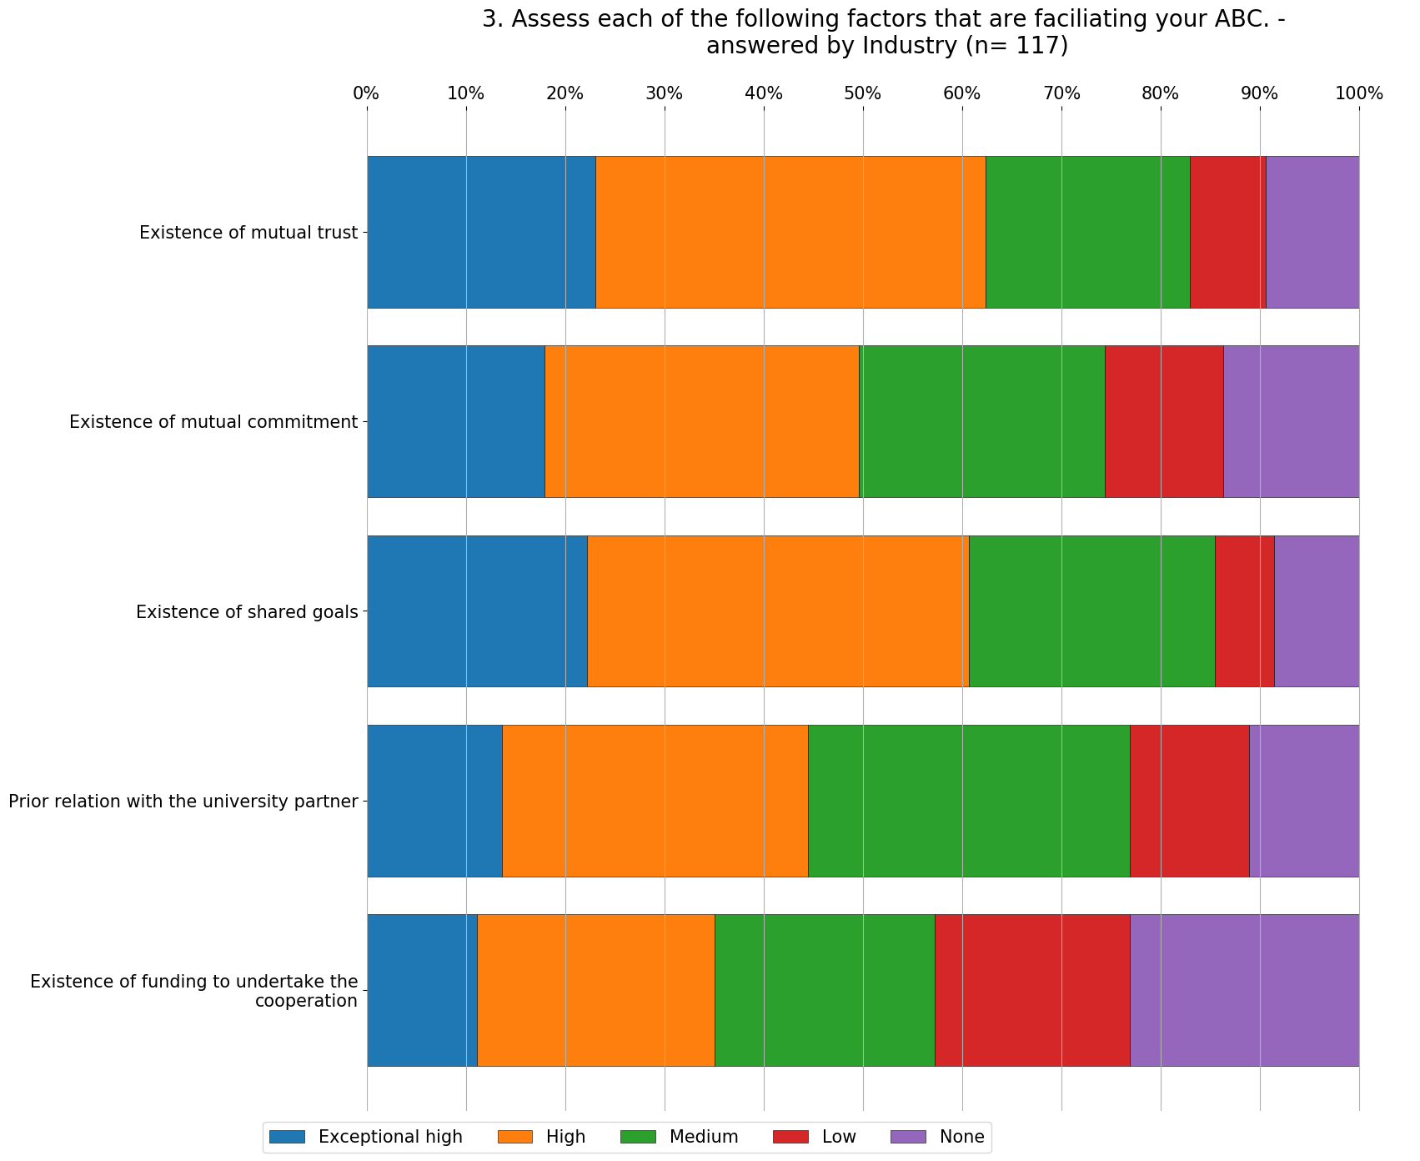

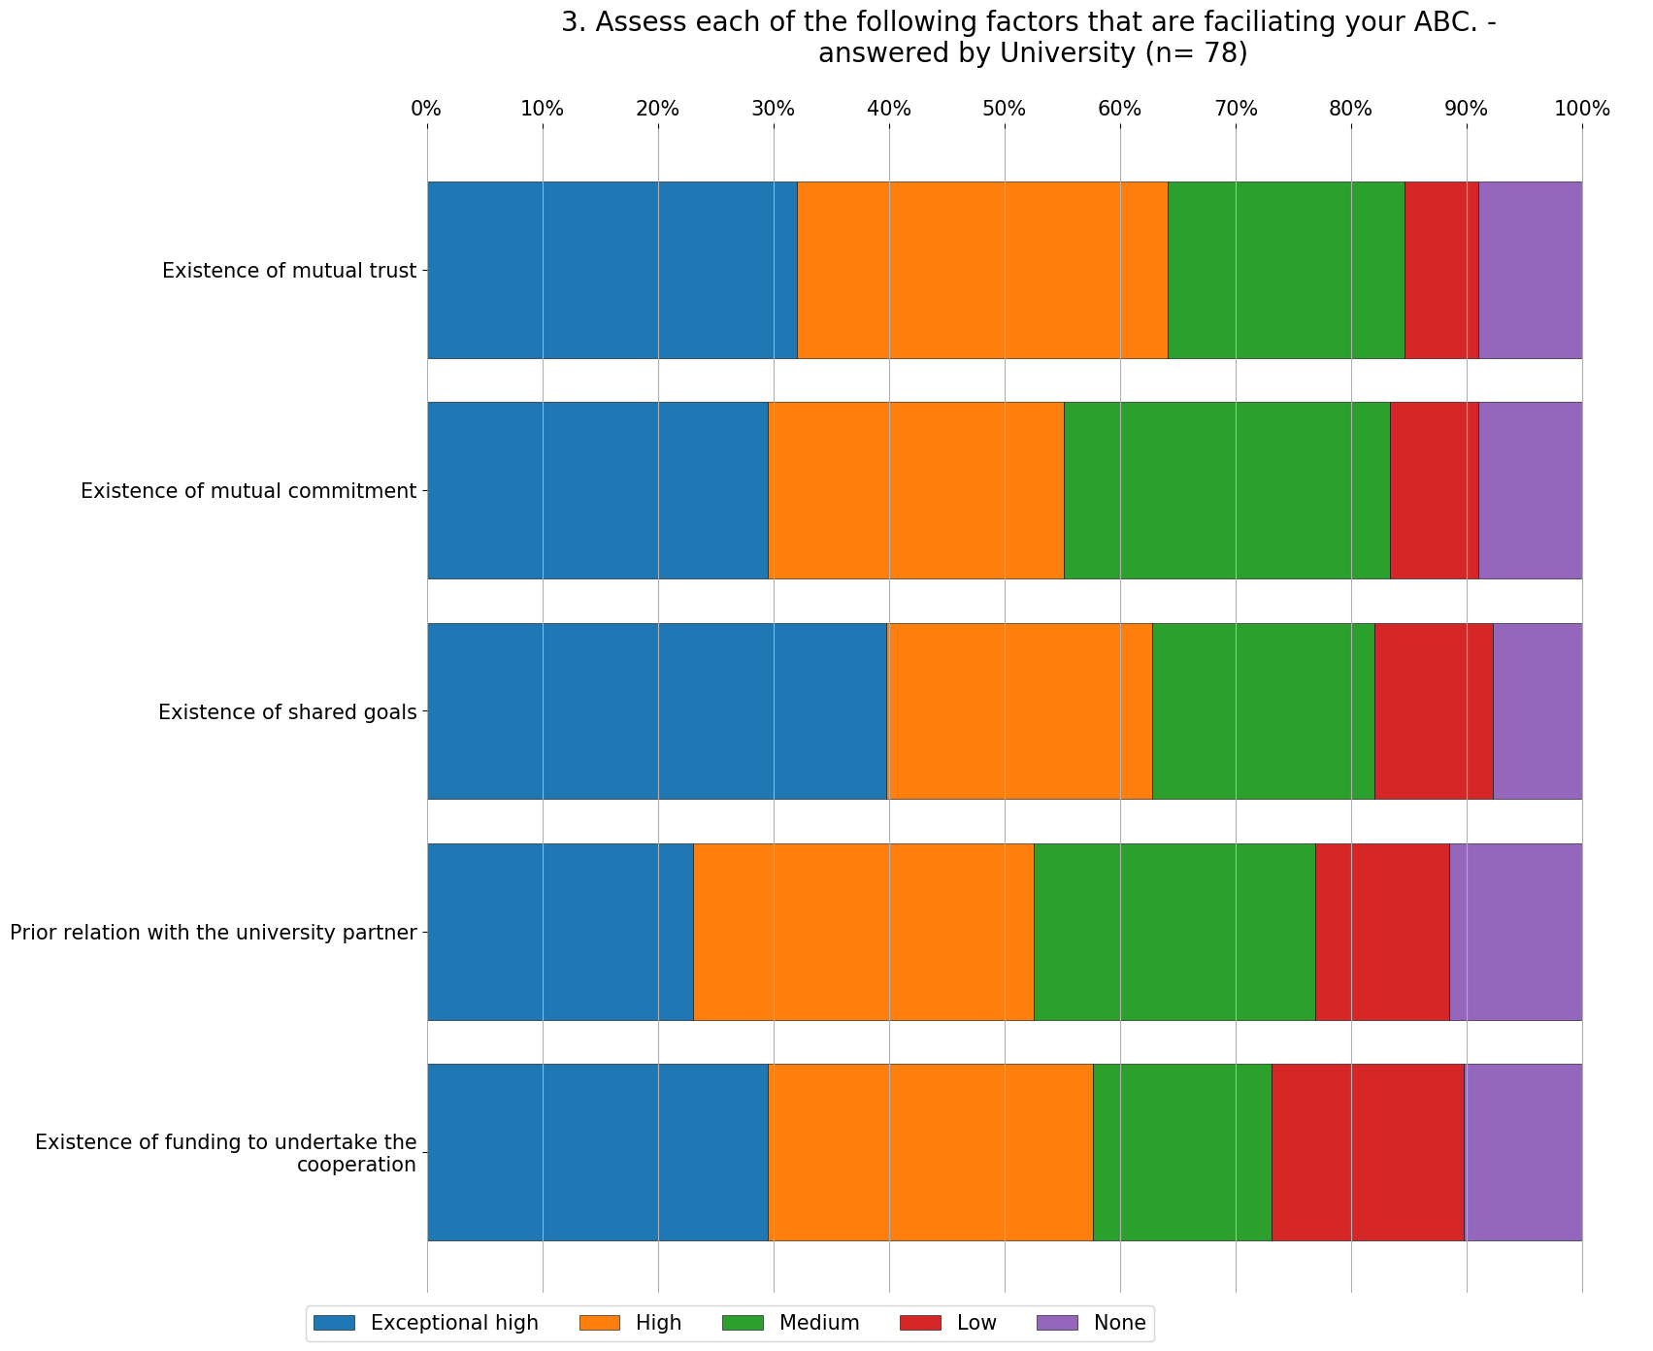

- On the question Which of the following factors motivates you to be a part of ABC, the respondents from Partner countries answered from exceptionally high and none for the following types of activities:

Respondents from partner countries rate most ABC motivators significantly high. They are mostly driven by the access to new technologies and knowledge, providing access to better qualified graduates and improving skills of current employees through training. Notably, obtaining funding and financial resources are the weakest drivers.

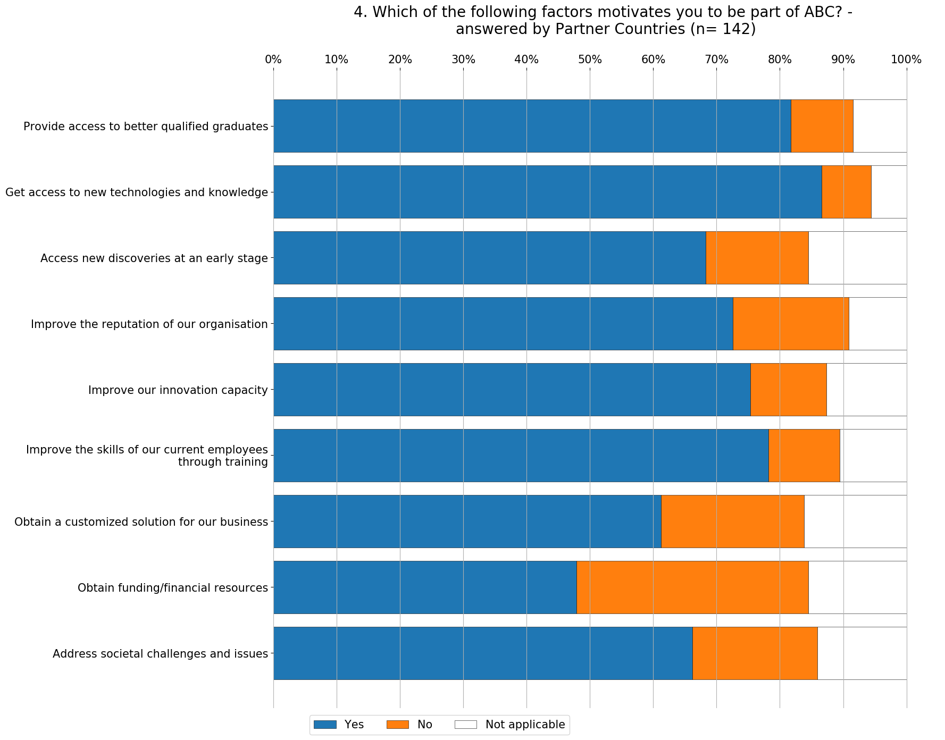
- On the question Assess each of the following factors that are inhibiting your ABC, the respondents from Partner countries answered from exceptionally high and none for the following types of activities:

Partner countries
Differing mode of communication and language between universities and business
Lack of people with scientific knowledge within business and with business knowledge within universities
Difficulty in finding the appropriate collaboration partner
Differing values and focus between university and business
Insufficient work time allocation for ABC activities
Bureaucracy related to ABC

The most hindering barrier to cooperation for Partner countries is the different mode of communication and language between universities and business.
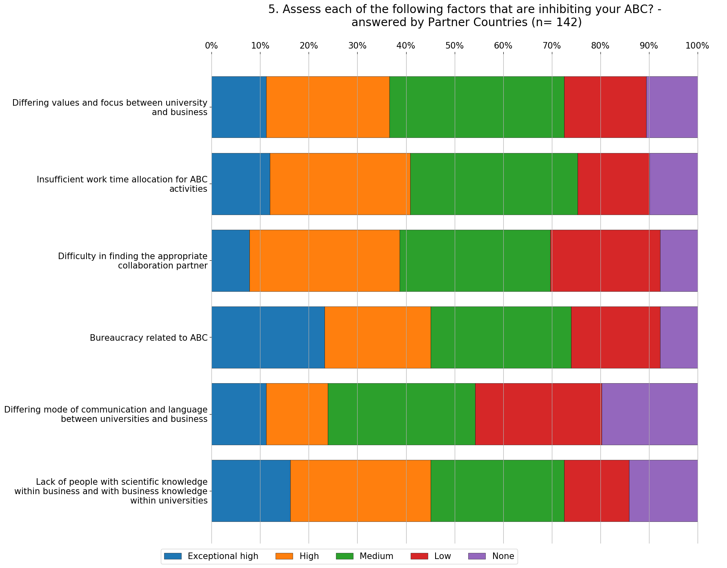

- On the question Assess each of the following factors that are inhibiting your ABC, the respondents from Industry and Universities answered from exceptionally high and none for the following types of activities:

Industry | Universities
Differing mode of communication and language between universities and business | Differing mode of communication and language between universities and business
Lack of people with scientific knowledge within business and with business knowledge within universities | Lack of people with scientific knowledge within business and with business knowledge within universities
Difficulty in finding the appropriate collaboration partner | Differing values and focus between university and business
Differing values and focus between university and business | Insufficient work time allocation for ABC activities
Insufficient work time allocation for ABC activities | Difficulty in finding the appropriate collaboration partner
Bureaucracy related to ABC | Bureaucracy related to ABC

The top two barriers, that all communication and lack of people, are very similar for both University and Industry representatives. The most hindering barrier to cooperation for both groups is the different mode of communication and language between universities and business. It can be point out that the least important inhibiting factor was Bureaucracy related to ABC from both groups, which is opposing the common perception that the lack of ABC is due to Bureaucracy.

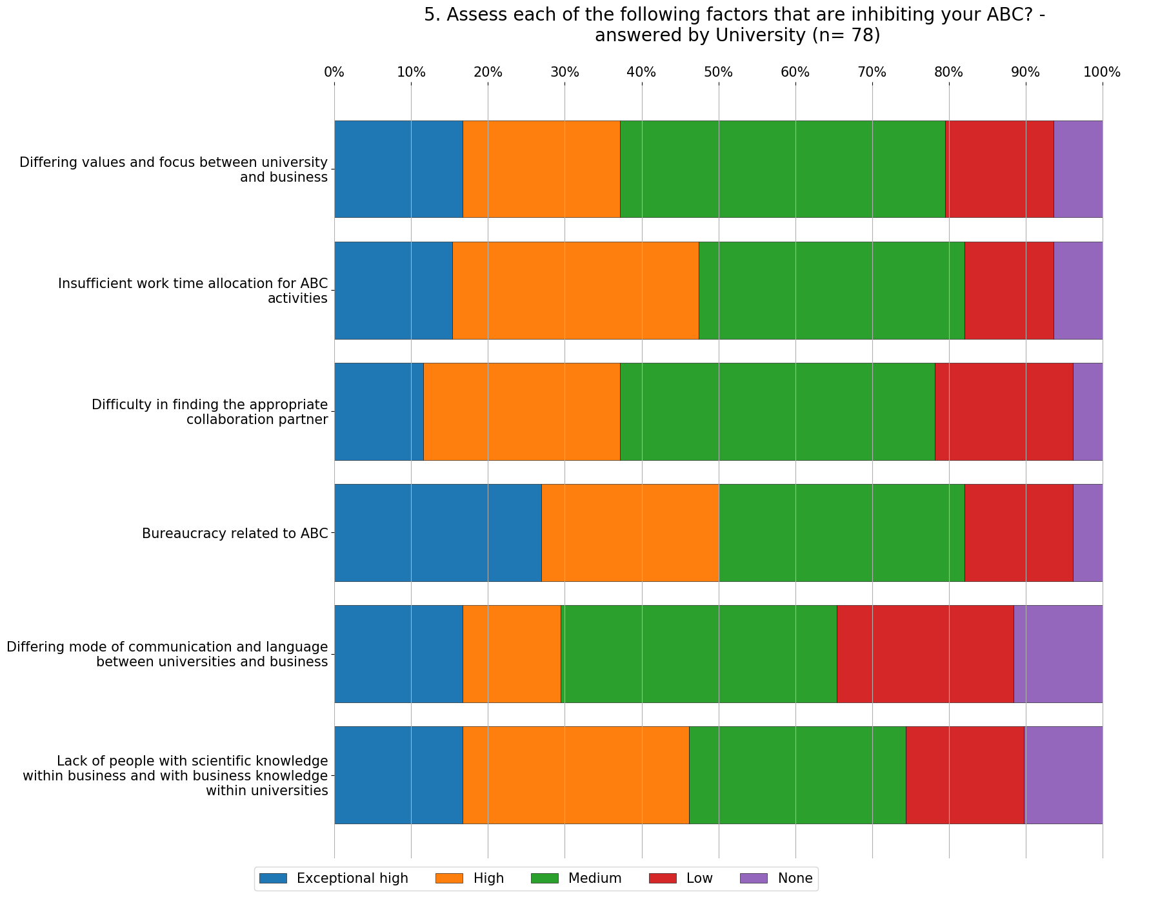

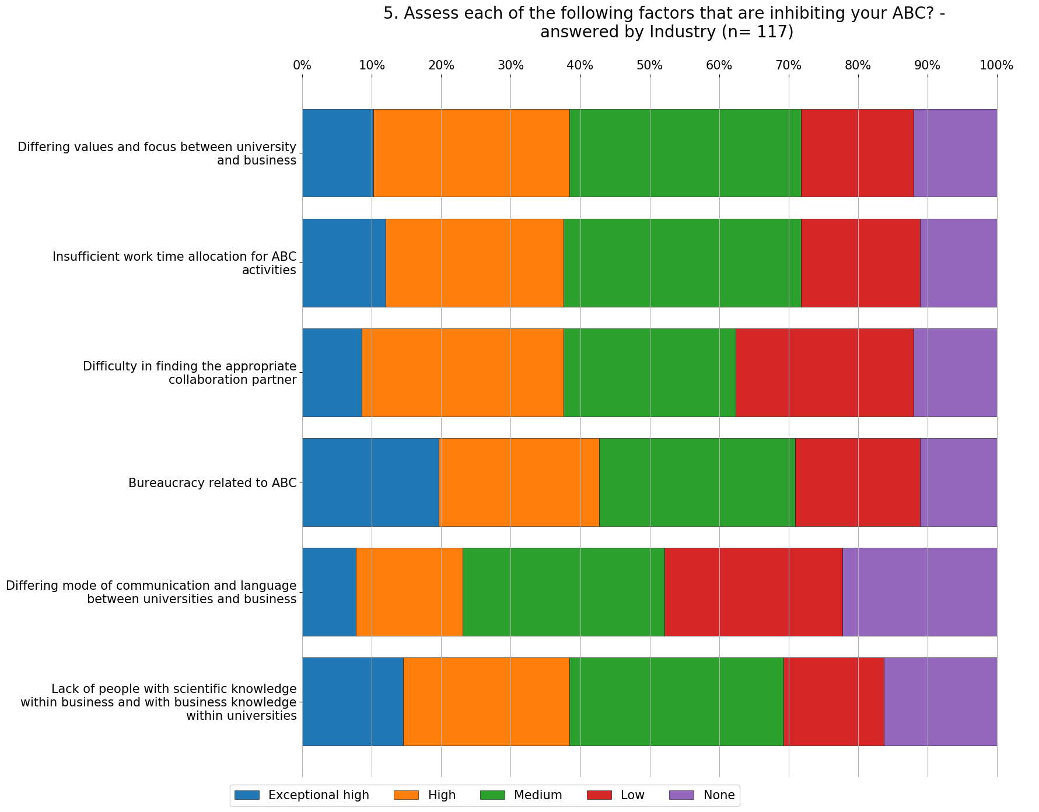

- On the question Assess each of the following factors that are barriers of ABC, the respondents from Industry answered from exceptionally high and none for the following types of activities:

Top 5 barriers (Exceptionally high) for Industry
- Bureaucracy in the university
- Lack of knowledge of the needs of firms
- Lack of professionals to dialogue with firms
- Problems on trust
- Differences on priorities

Top 5 barriers (Exceptionally high) for University
- Costs
- Bureaucracy in the university
- Lack of professionals to dialogue with firms
- Differences on priorities
- Bureaucracy in firms

The top five barriers identified by the respondents are related to resources and cultural issues. The most hindering barrier for the Industry is the Bureaucracy in the university, which is listed as a second most important barrier for Universities. The costs are listed as the top barrier at Universities which is connected to the limited university funding and limited resources of the Universities. It is important to point out that the Industry does not perceive the Costs in the top 5 barriers.

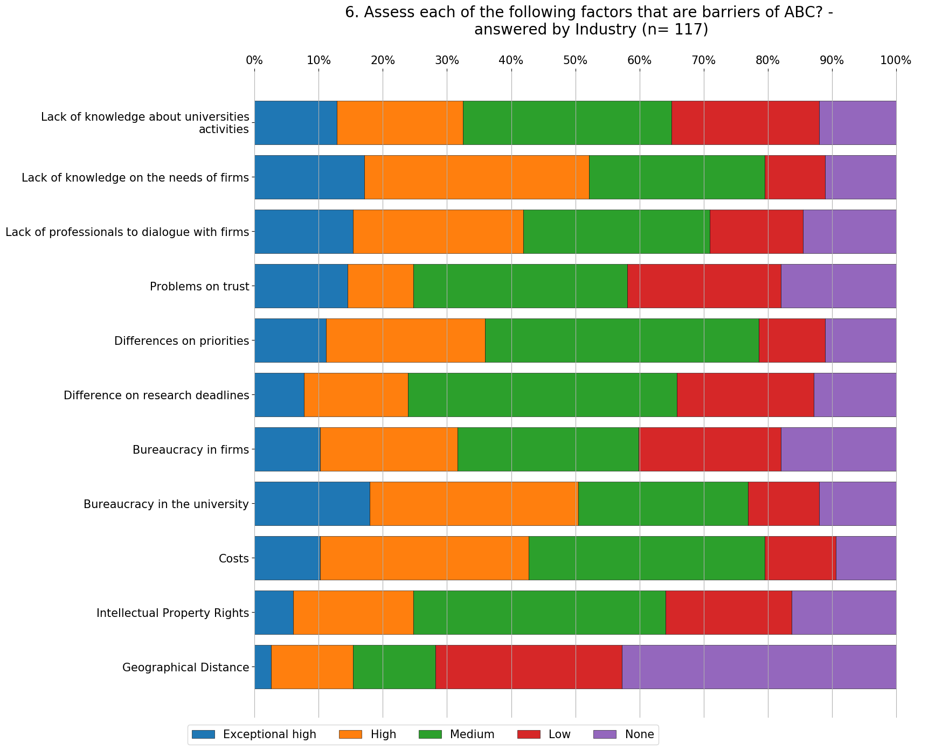
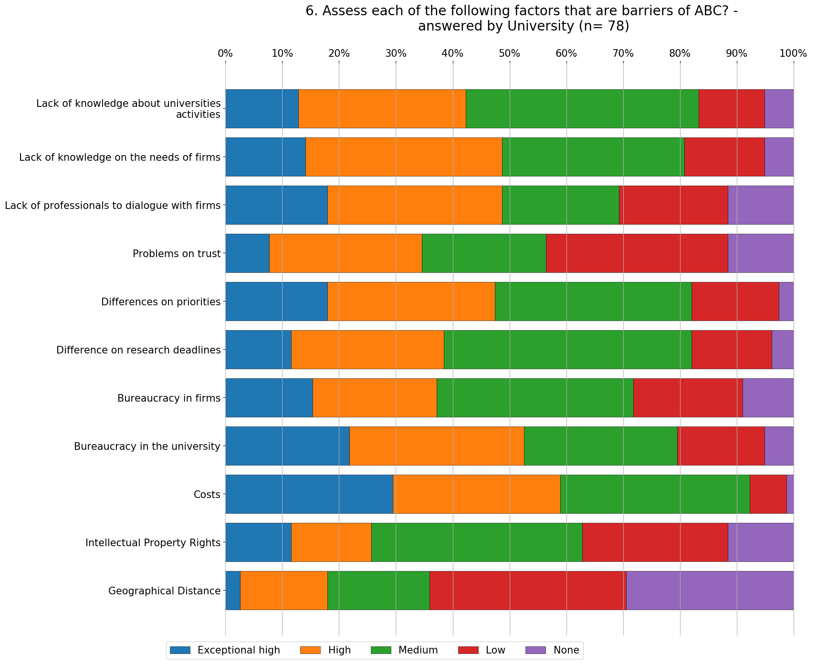

- On the question Do these supporting mechanism for ABC exist in your organization, answered from yes to no.

Top 3 supporting mechanisms for Industry
- Laws / rules / hiring policies positively supporting labour mobility between university and business
- The allocation of sufficient work time for staff to undertake collaboration with universities
- Policies positively supporting research collaboration between university and business

Top 3 supporting mechanisms for University
- Networking sessions or meetings for our employees to interact with academics
- A strategy supporting ABC
- Laws / rules / hiring policies positively supporting labour mobility between university and business

Top 3 supporting mechanisms for Partner countries
- Laws / rules / hiring policies positively supporting labour mobility between university and business
- The practice of recruiting PhD students or scientists into
- The allocation of sufficient work time for staff to undertake collaboration with universities

Top 3 supporting mechanisms for Program countries
- A strategy supporting ABC
- Policies positively supporting research collaboration between university and business
- Networking sessions or meetings for our employees to interact with academics

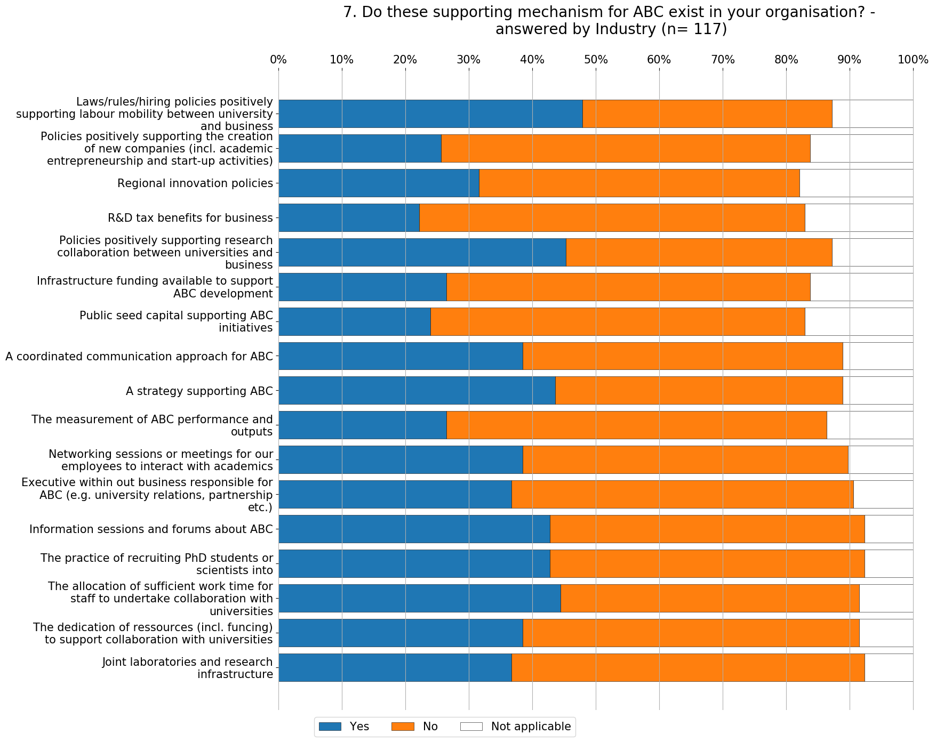

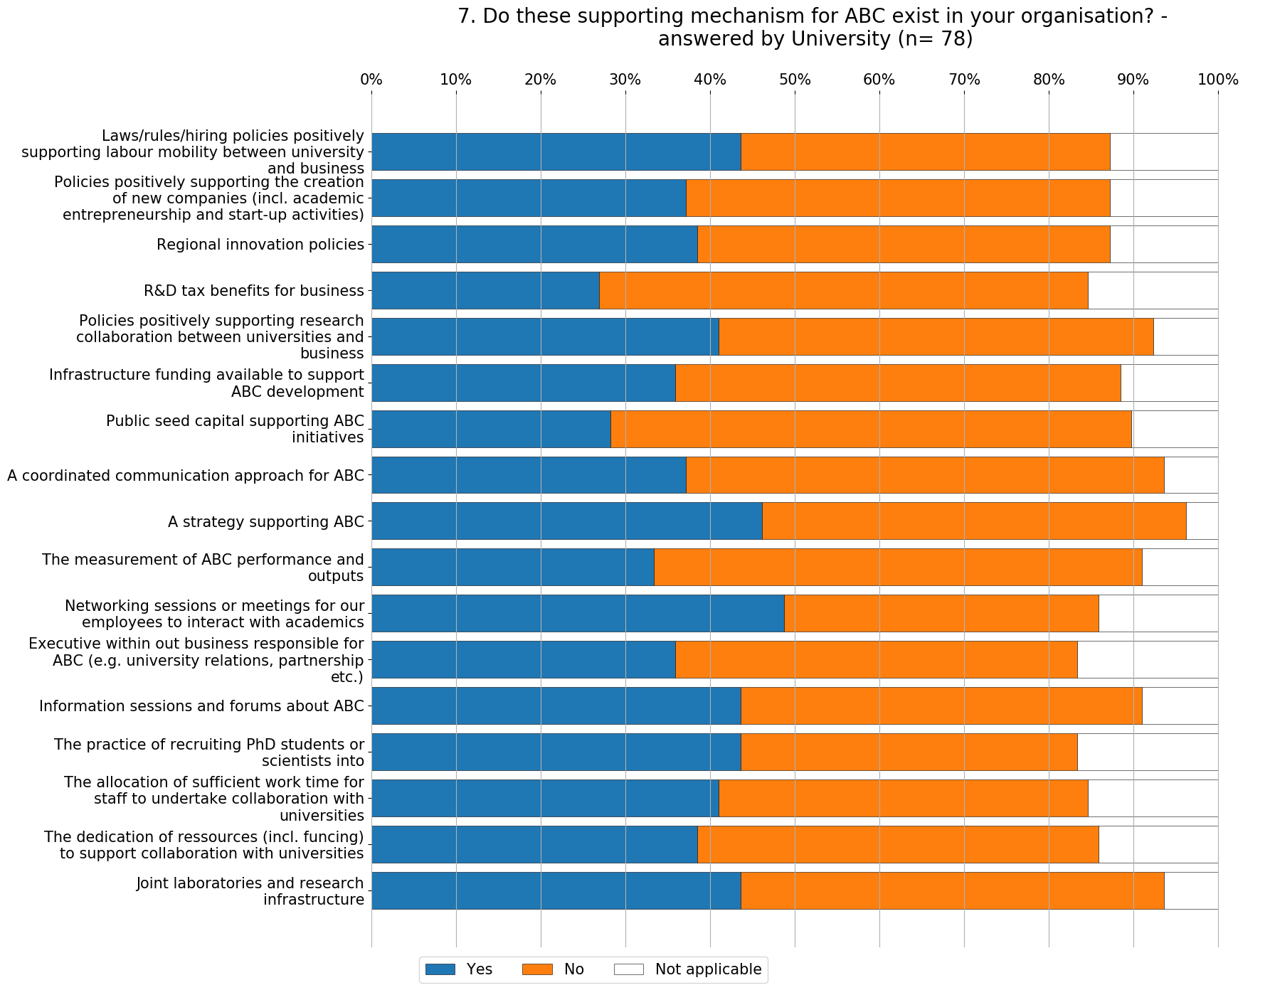

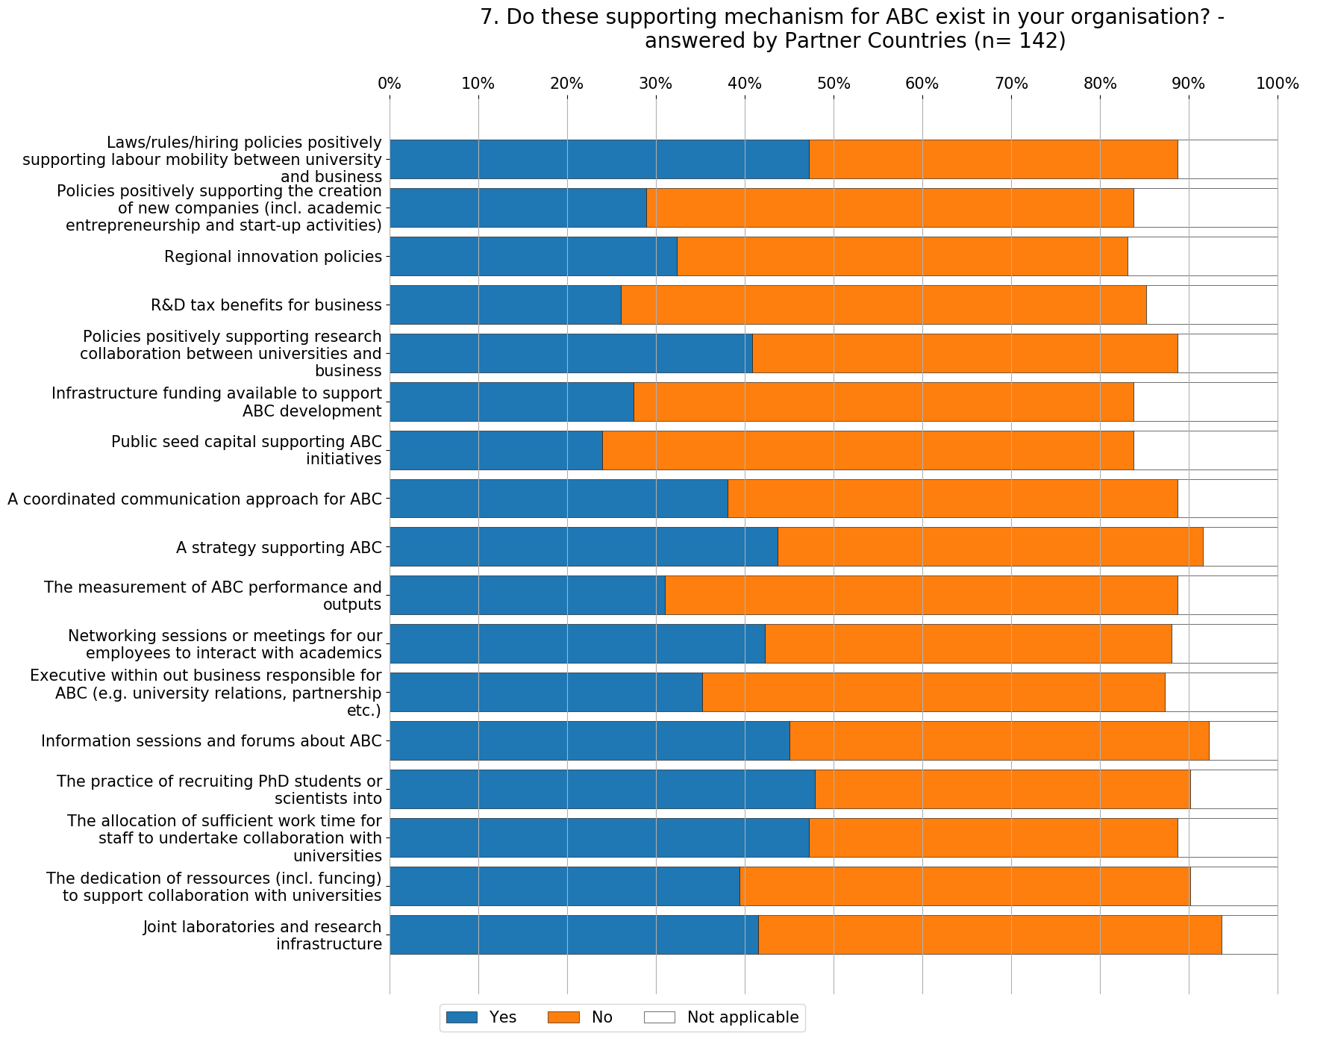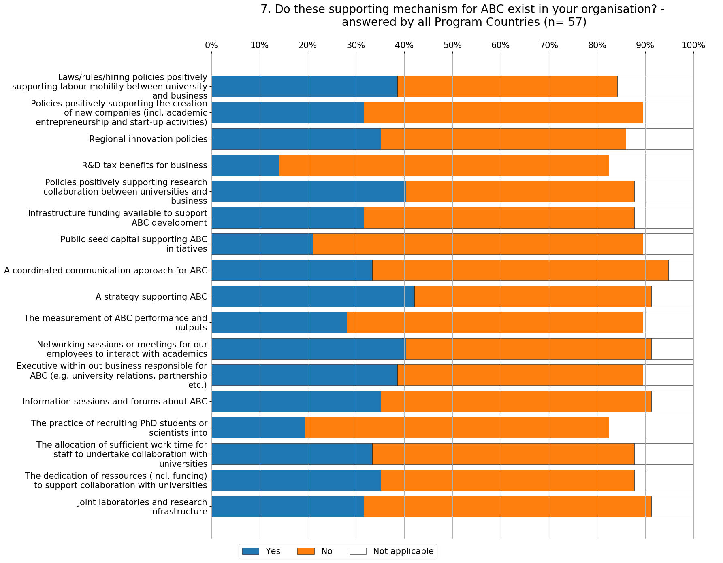

- On the question Assess the importance of each result from ABC the respondents from Industry and Universities answered from exceptionally high and none.

Top 3 important results for Industry
- Closing the gap between for educational needs and technology trends
- New research projects
- New Scientific Discoveries

Top 3 important results for University
- Training
- Improvement in manufacturing process
- New research objects

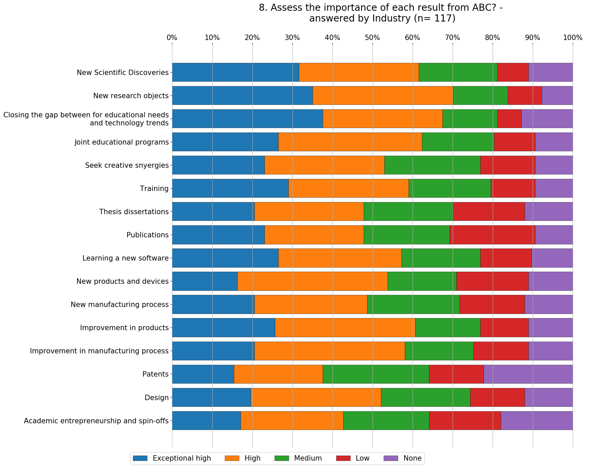
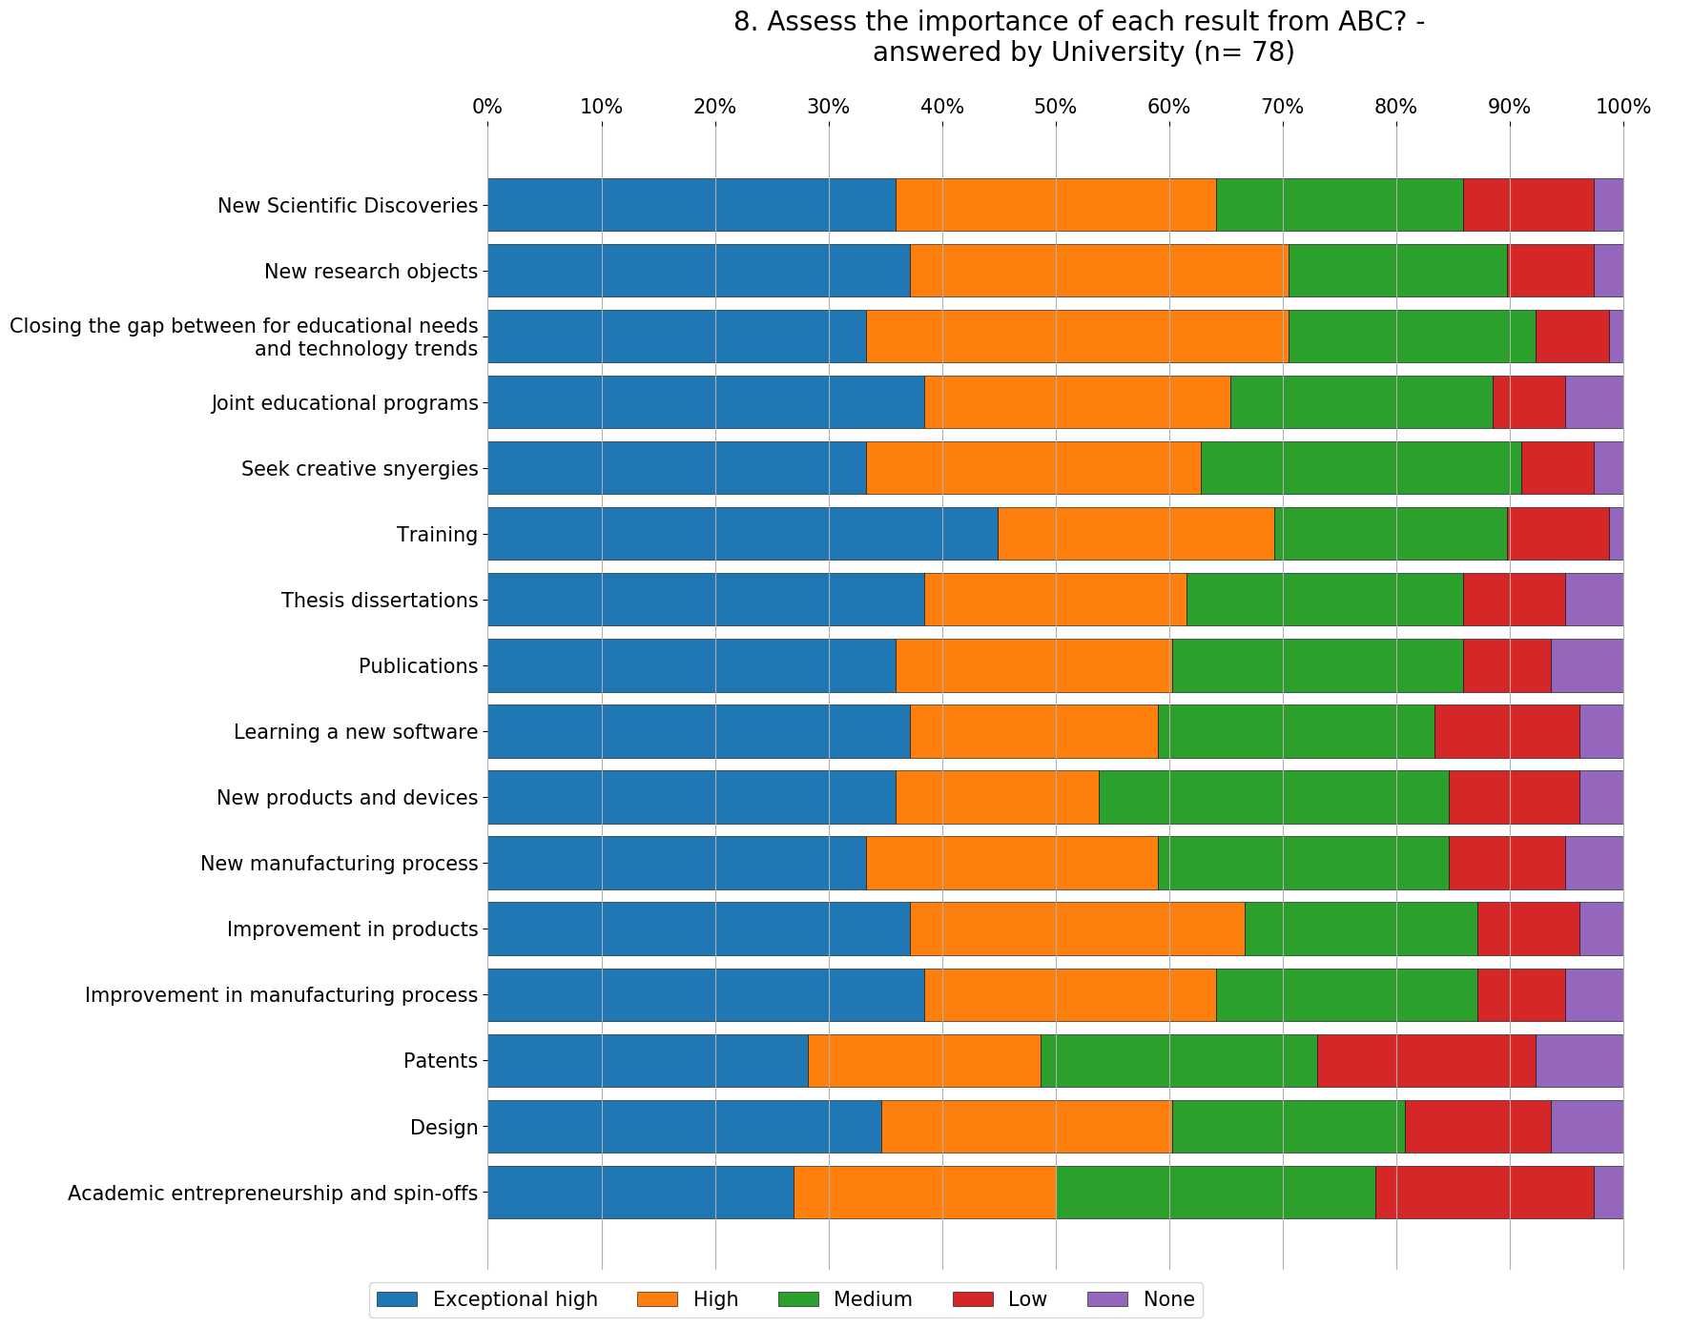

Self-assessment of R&D&I of partner institutions from Armenia and Bosnia and Herzegovina

Before reflecting on organizational level and assessing the potential of organisations, it is important to have information relevant on macro level in both countries. In B&H and Armenia there are structural challenges of the R&D&I system:
- Inefficient governance of the innovation system;
- Insufficient investments;
- Weak science-industry linkages; and
- Low capacity for innovation by the companies.
Several strategies, the Western Balkan Regional R&D Strategy for Innovation, the Strategy for South East Europe 2020, Innovation policy for Armenia, put special focus on strategic investments to facilitate academia-industry collaborations. This collaboration is seen to engage the quality and quantity of research outputs and their relevance to the economy.

Self-assessment and data collection on the R&D&I potential by partners from Bosnia and Herzegovina and Armenia was done with a questionnaire for measuring Intellectual capital that was answered by the eight partners from the Partner countries.
Intellectual capital is synergy of the value of an organization that comes from the knowledge of its employees, abilities, experience, relationships, attitudes, processes, influence on the community and everything that can create a competitive advantage. In short, intellectual capital refers to the use of knowledge in the creation of a new added value.
The questionnaire for measuring Intellectual capital was conducted via online assessment and it contained 57 questions, categorized in 3 categories: Human capital, Structural capital and Relational capital.
Human capital - the primary element and the driving force of the other two; the collective capacity of the organisation to create the best solutions using the knowledge of the employees. In this category there are 15 questions, divided in three sub-categories: Learning and education, Experience and expertise and innovation and creation.
Structural capital - the organisation's organisational capacity to meet market demands (technologies, strategy, patents, publications, policies, procedures and systems) - intellectual property and infrastructure facilities. In this category there are 15 questions, divided in three sub-categories: Systems and programs, Research and development and Intellectual Property Rights.
Relational capital - knowledge embedded in the organisation's relationships with its customers, suppliers, partners and other stakeholders. In this category there are 15 questions, divided in three sub-categories: Strategic partnerships, licensing and agreements, Brand Organisation and Customer Relationship and Suppliers, Knowing the clients and associates?

The survey was conducted at end of 2018 and the goal is that by the end of the project – (October 2021) the 8 organisations will answer the same questionnaire again, in order to measure the indicators after the project is done and its effects on the R&D&I potential in their organisation.
The assertions in the questionnaire relate to the intellectual capital and the effects it has on the organization’s business performance. The grading of each assentation is from 1-5:
- 1 - I totally disagree
- 2 - I do not agree
- 3 - neutral
- 4 - I agree
- 5 - I totally agree
On the following pages results from the responses of partner organisations from B&H and Armenia are presented.

Intellectual capital

The total grade of Intellectual capital for each organsiation is shown on Figure 1. The highest rating - 4,4. is assessed by YeTRI from the Companies and from the Universities NUACA has assessed the highest rating - 4,2. HP has the lowest rating – 2,9 from the Companies and from the Universities UNMO has the lowest rating – 3,1. It can be concluded that the ratings between the partners (univertisty-company), marked with the same color on Figure 1 for each R&D unit are correlated. This overview of the Intellectual capital in the organisaitons gives clear picture of the position of the partners regarding their current state and points out the aspects that the organisations should further develop.

Figure 1. Assessment of Intellectual capital by partners from Armenia and Bosnia and Herzegovina

On figure 2, the summary results of the three categories of Intellectual capital are represented.

Figure 2. Average of the assessment of human capital, structural capital and relation capital by partners from Armenia and Bosnia and Herzegovina

The highest score is assessed for Relational capital, which includes some of the following activities: working on joint projects, various channels of distribution and cooperation, monitoring of customer satisfaction, a long-standing relationship with suppliers, useful and updated information systems, receives customer feedback etc. Human capital and structural capital were both scored with 3,6, which leads to the conclusion that there is a potential for the organisations to improve the assessed score in the next three years, by involving their employees in activities from the project that are connected to WP2, WP3 and WP4.

Human capital

Human capital, as a category of Intellectual capital can be defined as the cumulative knowledge, skill, and experience of the organization's employees and managers. Organisations can invest in Human capital by investing in Development of skills of their employees and the return for the organisations from investing in Human capital are higher level of earnings, greater job satisfaction, better career prospects and more secure employment.
The 15 questions that are asked in this category are divided in three sub-categories: Learning and education, Experience and expertise and innovation and creation. The highest rating - 4,4. is assessed by YeTRI from the Companies and from the Universities NUACA has assessed the highest rating - 4,1. HP has the lowest rating – 2,8 from the Companies and from the Universities UNMO has the lowest rating – 2,7.

Figure 3. Assessment of Human capital by the partners from Armenia and Bosnia and Herzegovina

It can be concluded that there is a potential for increasing the Human Capital, especially from the partners located in Mostar (HP & UNMO). This assessment points out the necessity to develop training courses, as part of WP3 that will increase the Human capital in the organisations.

Structural capital

Structural capital is the embodiment empowerment and supportive infrastructure of human capital. It is also the organizational capacity, including the physical systems used to transmit and store intellectual material. Structural capital is defined as the knowledge that stays within the firm. It comprises organisational routines, procedures, systems, cultures and databases
In this category there are 15 questions, divided in three sub-categories: Systems and programs, Research and development and Intellectual Property Rights. The highest rating - 4,4. is assessed by YeTRI from the Companies and from the Universities NUACA has assessed the highest rating - 4,1. HP has the lowest rating – 2,3 from the Companies and from the Universities UNMO has the lowest rating – 3,1.

Figure 4. Assessment of Structural capital by the partners from Armenia and Bosnia and Herzegovina

It can be concluded that there is a potential for increasing the Human Capital, especially from the partners located in Mostar (HP & UNMO). This assessment points out the necessity to develop training courses, as part of WP3 that will increase the Human capital in the organisations.

Relational capital

Relational capital, as a category of Intellectual capital is defined as all resources linked to the external relationships of the firm – with customers, suppliers or partners in research and development. It comprises that part of human and structural capital involved with the company’s relations with stakeholders (investors, creditors, customers, suppliers), plus the perceptions that they hold about the company. Examples of this are image, customer loyalty, customer satisfaction, links with suppliers, commercial power, negotiating capacity with financial entities and environmental activities
In this category there are 15 questions, divided in three sub-categories: Strategic partnerships, licensing and agreements, Brand Organisation and Customer Relationship and Suppliers, Knowing the clients and associates. The highest rating - 4,3. is assessed by YeTRI from the Companies and from the Universities NUACA has assessed the highest rating - 4,5. IIAP has the lowest rating – 2,5 from the Companies and from the Universities UNMO has the lowest rating – 3,4.

Figure 5. Assessment of Relational capital by the partners from Armenia and Bosnia and Herzegovina

It can be concluded that there is a potential for increasing the Human Capital, especially from the partners located in Mostar (HP & UNMO). This assessment points out the necessity to develop training courses, as part of WP3 that will increase the Human capital in the organisations.

Collection of good practices in R&D and collaboration between academia and industry in program countries partner institutions

Good practices at UKIM

UKIM, presented case studies of several joint project research, pointing out the specific of these type of projects, offering practical advices and recommendations how similar activities can be foreseen in B&H and Armenia. The topics of the joint research projects are engineering, part of the civil engineering area, and related mostly to construction industry.
One very important aspect that was stressed is the motivation of all parties involved in the joint research projects. The motivation can be related to testing new product/service, designing new product, investigation of new material, etc. Also, important to emphasize is the wider environment, societal conditions, different phenomena and natural circumstances (e.g. having a strong earthquake as inspiration for new research, receiving new data, updating the city plans and increasing safety).
To have a good practice it is important to find mutual interest and topics for research. It was explained that this process is crucial for the following steps in long-term collaboration between academia and industry. Also, having clear expectations, and defined the role of each involved party is very important, and should be done thoroughly.
Usually, the joint research projects offer easier possibility to work in interdisciplinary teams and explore complex, interdisciplinary topics.
The projects presented had their area of activity in:
- Research project STREP: earthquake engineering, seismic behavior of masonry, strengthening techniques and methods;
- Research project MPC: earthquake engineering, testing new hardware products and equipment for Structural health monitoring applications;
- Research project SeismoWall: earthquake engineering, seismic risk mitigation.
From the knowledge and experiences gained through the projects (STREP, MPC and SeismoWall and others), can be concluded that the following aspects are important for strong ABC:
- Clear structure at the beginning of the project and defining project phases is recommended;
- Defining the budget and duration of the projects are next steps. In the experiences of UKIM, these joint research projects last from 1 – 2 years, inviting different type of staff (professors, junior researchers, technicians, students) to be part;
- Mutual interest and expectations on the benefits from the collaboration. Satisfaction is higher for all parties involved, if the needs are properly addressed and the results match the expectations;
- Communicating the process of the cooperation, as well as the results from the ABC is important. This way visibility of the projects is higher, and also, new interested institutions can express interest to participate in similar activities.
Although small in scale these joint research projects and firm academia-industry collaboration brings many benefits. For academia some of the benefits are: publications on conferences and scientific journals, master and doctoral thesis, new project funded, impact in society. Industry on the other hand gain new knowledge, skillful employees, new expertise in specific fields, applicable solutions, alert management, boosting the innovation potential and on long term higher competitiveness. Very important, these collaborations bring benefits to the society and wider community as well. In the cases presented, benefits for the society were: increasing the seismic resistance of existing buildings, safer homes and people protection from earthquake events, longer life span, detecting early safety risks, cost reductions, etc.

Good practices at IECE

The presentation of IECE on good practices on ABC was more focused on the process of establishing partnerships and ensuring high quality collaboration. Few examples of different modes of collaboration were mentioned as illustration of the functionality of the presented model, and aligned with achieved results.
Having in mind that N. Macedonia is developing country, with many challenges, one has to be aware that university-industry partnerships does not come naturally and requires great effort to be established and maintained. Some facts about developing countries on macro level are influencing the climate of collaboration and innovation. In developing countries, there are many challenges:
- Lack of funding in R&D&I from public and private sector
- Superficial and formal university-industry collaboration and poor linkages
- Lack of trust and uncertainty about the benefits of working together
- Lack of vision and long-term strategies in many organisations
IECE in the last 5 years conducted scientific research (as joint research project between IECE, Faculty of Economics and one company) and developed functional model for academia-industry collaboration. One aspect of the research was to investigate the return on investment in science and human capital, having the Civil Engineering Institute Macedonia – CEIM as a case study. One important result from the research is a model for measuring the economic benefits of investing in science and human capital. Very promising are the positive results received from measuring the benefits (quantitative and qualitative) of investments in science and the level of increased potentials of human capital, while proposing effective methods for transformation into intellectual capital that will contribute to increased productivity and competitiveness of the Civil Engineering Institute Macedonia - CEIM.
The CO-IN model that was developed is a unique and tailor-made model, designed to establish and enhance collaborative and innovative (CO-IN) partnerships. CO-IN model aims to solve complex, dynamic, and networked problems using frame innovation, and transforms traditional organisations into sustainable systems adapting toward the 4th industrial revolution.

The CO-IN model, developed and tested in the last 5 years, has proven successful, in many aspects:
- Powerful engine for innovation and economic growth in developing countries;
- Strategic university-industry partnerships contributing to boost research, innovation, knowledge and technology transfer aligned with governmental policies and strategies;
- Progress towards 4th generation Universities and learning organisations; and
- Significant impact on personal, organizational and societal level.

Good practices at RUB

The presentation of good practices on academia-industry collaboration at RUB pointed out different mechanism of cooperation and support, as well as funding possibilities for this cooperation. Modes of cooperation mentioned were: contract research and development, transfer of technology, spin-offs and start-ups, and joint applications. Along with each mode of cooperation, the benefits for both university and industry were elaborated. Here briefly, we present some of the content and conclusions. Full presentation of good practices at RUB is in Annex.
Good practice 1: Traditional cooperation among industry and academia – contract research
Area of activity – Wind engineering, Fluid Mechanics, Dynamics of structures, Environmental techniques
Structure/Activities – Tax-exempted commercial branch of university unit without contravening European law on state aid
Good practice 2: Spin-offs as consulting companies
Case of company for consulting activities in wind engineering (civil engineering sector): Niemann & Partner, founded 2000 as spin off from the university unit “Building Aerodynamics Laboratory”
Technological areas: Wind engineering, Fluid Mechanics, Dynamics of structures, Environmental techniques
Good practice 3: World Factory
The vision of World Factory is to strengthen and expand cooperation between science and industry and the exchange of know-how, consolidate the university business association, increase start-up activities, as well to invite companies to locate and to develop international appeal in order to acquire and implement talents and projects worldwide.
Activity of expertise: Start-up consulting, Patent consulting, Makerforum – Coworking – Team-space, and Transfer of Knowledge and Technology.

Benefits for University and Industry
- Preservation, maintenance and extension of research/experimental facilities;
- Competent use of experimental and numerical laboratories;
- Knowledge transfer from university into engineering practice;
- Collaborative exchange of applicative demands;
- Joint publications;
- Contact to university sources of competent human capital;
- Transfer of technology;
- Matching entrepreneurs with scientists;
- Practice-/project-oriented events; and
- Consulting for application-oriented R&D projects.

Good practices at UVA

Overall in Finland, of the total spending in R&D of about 6 billion, companies spend about two thirds, government and universities about one third. Industry in Vaasa is very much concentrated around energy generation and transfer; main company Wartsila produces big diesels for power stations and shipbuilding, the second biggest company ABB makes special transformers, wind power generators, electric motors and third protection relays. In this region 175 million euro or 3,5 % of GNP are spend in R&D.
The Finnish Higher Education system – two types of universities, traditional universities and universities of applied sciences. The two Higher Education sectors are meant to take care of clearly different tasks. The “traditional Universities’” Law states the Universities “shall conduct scientific research, and give highest tuition based on said research”. The Universities of Applied Sciences (UAS) shall, according to the UAS Law, “develop skill and knowledge to the work-life of their region, and help develop the region”. Furthermore, due to the “working-life skills” requirement, the UAS four-year Bachelor studies include obligatory one-year work-life practice, while the “traditional universities” Bachelor studies are just three years. The Universities of Applied Sciences are, due to their regional ownership and region development responsibility, mostly selling their services directly to the company/private sector, and the projects are also relatively small (e. g. testing of a prototype).
The Traditional Universities’ R&D funding comes from their basic funding budget, the Academy of Finland, TEKES, and the EU international funds (e g Frame Programmes) while the Universities of Applied Sciences’ funding is mainly from regional development funds (e g ERDF, Bothnia Atlantica), the companies, and the owning municipalities. Also, the time frame of the research projects of the Traditional Universities is typically of several years, while the UAS do mostly applied research projects of less than one year with the companies. This is not legally bound to be so; it is more a function of the different approaches to R&D and the connection to local industries’ needs.
There are some specifics how the cooperation among industry and academia is set:
  - Dedicated staff from academia to continuously communicate with companies on weakly basis;
  - Established long-term, everyday contacts with the major companies;
  - Signed cooperation agreements with defined roles and expectations;
  - Developed annual research plan;
  - Assessing the needs of the companies;
  - Functional Technology Transfer office;
  - Upgrading the curricula every five years, working jointly, taking in consideration the needs and requirements of companies and new technology trends;
  - Annual evaluation of implemented joint activities;
  - Encouraging new fields of research to be introduced, providing “seed funding”, usually regionally-funded research.

Recommendation for strengthening of academia – industry cooperation

Results from the academia-business collaboration (ABC) survey suggest that there is room for improvement of ABC. It was noted that most ABC activities (50% or more of the respondents) have low or no experience. Additionally, many collaborative projects are not conducted regularly, such as Student undertaking industrial training, Technology development, Idea testing. Most common main barriers of ABC found were: lack of supporting mechanisms for ABC, lack of knowledge on the needs of firms, lack of professionals to dialogue with firms, bureaucracy in the universities and costs.
Both staff from academia and industry see and expect many benefits from the ABC, such as: joint research projects, access to technology and knowledge, and better graduated students and workforce. It is expected that with continuous collaboration the gap for educational needs and industrial trends to be closed, as confirmed in the presented good practices in Finland and Germany.
Good practices in Finland and Germany include higher investments in R&D, focus on regional development, innovation driven companies, introducing latest technology trends (e.g. digitalization, automation and AI).
UVA and RUB have very well developed and long term cooperation with the industry and they are fulfilling their role as the driver of innovation in their region. They are following the current trends and are constantly developing new instruments to respond to the current challenges in cooperation with the industry.
Even though in N. Macedonia there is a lack of investments in science, and similar economic and social conditions as B&H and Armenia, UKIM and IECE found a way to spur research activities and collaborate with many business partners. This similarity is seen as an advantage in this project and will contribute to mutual understanding, on one hand, but also, inspiration, on the other.
One of the recommendations relevant for B&H and Armenia is being inspired and motivated to replicate the model that UKIM and IECE established. The cooperation between UKIM and IECE and the shared vision on the potential university-industry alliances can be seen as really possible and practical tool when establishing the Cooperative R&D units in B&H and Armenia. This is especially important because of the many similar challenges these countries have, and using the best possible mode to positively influence of R&D&I inviting many stakeholders to engage.
The CO-IN model is unique and innovative, providing useful knowledge and added value from research and education. The model is value based, on trust and openness. It requires long term sustainable thinking, systematic approach, and ensures synergy and exceptional collaboration among the involved parties. CO-IN model can be used for solving/ tackling complex, open and dynamic problems, utilizing the frame creation methodology to promote new sustainable solutions and change in thinking patterns.
The CO-IN model, developed and tested in the last 5 years, has proven successful, in many aspects:
- Powerful engine for innovation and economic growth in developing countries;
- Strategic university-industry partnerships contributing to boost research, innovation, knowledge and technology transfer aligned with governmental policies and strategies;
- Progress towards 4th generation Universities and learning organisations; and
- Significant impact on personal, organizational and societal level.
The CO-IN model can be replicated, enhancing long-term success and innovation, contributing to added value and useful knowledge, sustainable partnerships, and well-being of individuals and organisations.

The academia-industry collaboration has effect, positive influence, and significant impact on personal, organizational and societal level:
- Effects and benefits for academia (publications, new researchers, more funds available, exploring innovative topics);
- For companies (commercialization, applicable and practical solutions relevant for every day operations, introducing new services or products to the market, knowledge for the employees on latest technologies, competitiveness); and
- Society (positive effects from the results, local and regional development, effects on health, quality of life, increased safety, new job openings).

Having in mind all the results and analysis from the survey, self-assessment and good practices, the following recommendations can be proposed:
  - Finding mutual interest and motivation to participate in ABC;
  - Established long-term, everyday contacts with the relevant stakeholders;
  - Structure the cooperation with signed cooperation agreements with defined roles and expectations;
  - Assessing the needs of the companies;
  - Developed annual research plan, with clear roles, responsibilities, budget, expectations, defined phses in the joint activities;
  - Dedicated staff from academia to continuously communicate with companies on weakly basis;
  - Encouraging new fields of research to be introduced, providing “seed funding”;
  - Contributing to society, solving every day, complex and multidisciplinary topics;
  - Annual evaluation of implemented joint activities.

In the WP1 the effort was to transfer the inspiration, to share this experience and know-how on establishing academia-industry alliances, especially in similar countries like N. Macedonia. The strategic purpose and the innovative character of the All4R&D project is to establish and implement cooperation and innovation model, in order to organise, mobilise, gather, lead and assign the optimal role to all stakeholders being directly interested in and affected by the progress of science and innovation. These Cooperative R&D Units will be positioned as an intermediary body that is bringing together universities and industry, with the role to develop sustainable and innovative solutions, enhance career progress and employability of students, and increase the investments in science by the business sector. The project does not offer a 'blueprint' or prefabricated 'quick fix' solutions; the participants from the involved universities and companies are in the driver's seat. The existing situation at the universities and companies in the partner countries is taken as point of departure for further development, but they are not alone in this.

Annexes

Questionnaire for Academia Business Collaboration (ABC)

Dear participant,
We kindly invite you to participate in the survey about the needs and challenges of Academia Business Collaboration (ABC).
Please, spare 15 minutes of your valuable time for this survey, which is part of the Erasmus + Project “Promoting academia-industry alliances for R&D through collaborative and open innovation platform - All4R&D”.
The questionnaire is anonymous. All data from this survey will be analyzed and presented exclusively for the project. The survey will be conducted in N. Macedonia, Bosnia and Herzegovina, Armenia, Finland, Austria and Germany.

ABC – Academia Business Collaboration
1 2 3 4 5
None Low Medium High Exceptional high
- In which ABC activities do you participate?
Education
- Curriculum co-development, co-design and co-delivery (e.g. guest lectures)
- Mobility of students (i.e. student internship/placements)
- Lifelong learning programmes for people from business (e.g. executive education, industry training and professional courses)
Research
- Joint R&D (incl. joint funded research)
- Mobility of professionals (i.e. temporary mobility of academics to business and vice versa)
Valorisation
- Comercialisation of R&D results (e.g. licensing/patenting)
- Spin offs
Management
- Governance (e.g. participations of academics on business boards and business people participation in university board)
- Shared resources (e.g. infrastructure, personnel, equipment)
- Other_____________

Yes No Not applicable

- What types of collaborative projects have you been involved in?
- Educational projects
- Joint research projects
- Student undertaking industrial training
- University consulting
- PhD or Master research
- Problem solving
- Technology development
- Idea testing
- Knowledge generation
- Joint publications

1 2 3 4 5
None Low Medium High Exceptional high
- Assess each of the following factors that are facilitating your ABC.
- Existing of mutual trust
- Existence of mutual commitment
- Existence of shared goal
- Prior relation with the university partner
- Existence of funding to undertake the cooperation

Yes No Not applicable
- Which of the following factors motivates you to be a part of ABC?
- Provide access to better qualified graduates
- Get access to new technologies and knowledge
- Access new discoveries at an early stage
- Improve the reputation of our organisation
- Improve our innovation capacity
- Improve the skills of our current employees through training
- Obtain a customized solution for our business
- Obtain funding / financial resources
- Address societal challenges and issues

1 2 3 4 5
None Low Medium High Exceptional high
- Assess each of the following factors that are inhibiting your ABC?
- Differing values and focus between university and business
- Insufficient work time allocation for ABC activities
- Difficulty in finding the appropriate collaboration partner
- Bureaucracy related to ABC
- Differing mode of communication and language between universities and business
- Lack of people with scientific knowledge within business and with business knowledge within universities

1 2 3 4 5
None Low Medium High Exceptional high
- Assess each of the following factors that are barriers of ABC?
Capabilities barriers
- Lack of knowledge about universities activities
- Lack of knowledge on the needs of firms
- Lack of professionals to dialogue with firms
- Problems on trust
Orientation Barriers
- Differences on priorities
- Difference on research deadlines
Transactional Barriers
- Bureaucracy in firms
- Bureaucracy in the university
- Costs
- Intellectual Property Rights
- Geographical Distance

Yes No Not applicable
- Do these supporting mechanism for ABC exist in your organisation?
Policy mechanisms
- Laws / rules / hiring policies positively supporting labour mobility between university and business
- Policies positively supporting the creation of new companies (incl. academic entrepreneurship and start-up activities)
- Regional innovation policies
- R&D tax benefits for business
- Policies positively supporting research collaboration between university and business
- Infrastructure funding available to support ABC development
- Public seed capital supporting ABC initiatives

Strategic mechanisms
- A coordinated communication approach for ABC
- A strategy supporting ABC
- The measurement of ABC performance and outputs
- Networking sessions or meetings for our employees to interact with academics
- Executive within our business responsible for ABC (e.g. university relations, partnership etc.)

Operational mechanisms
- Information sessions and forums about ABC
- The practice of recruiting PhD students or scientists into
- The allocation of sufficient work time for staff to undertake collaboration with universities
- The dedication of resources (incl. funding) to support collaboration with universities
- Joint laboratories and research infrastructure

1 2 3 4 5
None Low Medium High Exceptional high
- Assess the importance of each result from ABC?
Knowledge results
- New Scientific Discoveries
- New research projects
- Closing the gap between for educational needs and technology trends
- Joint educational programs
- Seek creative synergies
- Training
- Thesis dissertations
- Publications
- Learning a new software
Commercial Results
- New products and devices
- New manufacturing process
- Improvement in products
- Improvement in manufacturing process
- Patents
- Design
- Academic entrepreneurship and spin-offs

Respondents profile

- Position of respondent ________________________

- Type of organisation
- Privately-owned company
- Public-owned company (stock-exchange listed)
- Public University
- Private University
- Public Research Institute
- Private Research Institute
- Other _______________

- Number of employees
- 1-9
- 10-49
- 50-249
- 250-999
- 1000+

- Main activity of the organisation? ________________________

- City in which you operate? _____________________

- Gender
- Male
- Female

- Age of respondents
- < 30
- 30-39
- 40-49
- 50-59
- 60-69
- > 70

- Level of education
- BSc. / BA
- MSc. / MA / MBA
- PhD
- Other

- Years working within the organisation
- 0-2
- 3-5
- 6-9
- 10-19
- 20+

- Year involved in ABC whilst working at a university or business
- 0-2
- 3-5
- 6-9
- 10-19
- 20+

During the All4R&D project we will develop numerous educational and research project, and establish innovative and collaborative online platform for academic and business organisations.
Would you like to be part of this online platform which will be created as a results from the project, where you can collaborate with national and international experts and organisations?
- Yes
- No

If yes, please leave your contact details so we can contact you for future activities.
- E-mail:

Survey results from self-assessment

Human capital
 | Learning and education | UNMO | UNSA | NPUA | NUACA | HP | WINNER | YETRI | IIAP
1. | Employee development is crucial for the survival of the organization. | 4 | 5 | 4 | 4 | 3 | 4 | 4 | 5
2. | The level of staff with higher education is on average in comparison with the industry (number of PhD, masters and graduates). | 4 | 2 | 4 | 5 | 2 | 3 | 4 | 3
3. | The organization devotes a lot of time and effort to upgrading and developing the knowledge and skills of its employees. | 2 | 5 | 4 | 4 | 3 | 5 | 4 | 3
4. | The organization manages the knowledge of employees. | 2 | 4 | 4 | 4 | 2 | 4 | 4 | 3
5. | Employee education affects the profitability of the organization. | 3 | 5 | 5 | 3 | 3 | 4 | 5 | 2

 | Experience and expertise | UNMO | UNSA | NPUA | NUACA | HP | WINNER | YETRI | IIAP
6. | The organisation's employees are experts in their fields. | 4 | 5 | 4 | 5 | 4 | 4 | 5 | 4
7. | The organisation's employees are constantly giving the best of themselves, which makes this organisation different from others in the industry. | 3 | 3 | 4 | 4 | 4 | 5 | 5 | 4
8. | The abandonment of some employees of the organisation will cause problems in the work. | 4 | 4 | 3 | 5 | 3 | 4 | 4 | 5
9. | For employees with specific knowledge, the organisation has specific motivation measures. | 1 | 3 | 2 | 2 | 2 | 4 | 4 | 2
10. | The experience and expertise of the employees affects the profitability of the organisation. | 4 | 4 | 3 | 4 | 4 | 5 | 5 | 2

 | Innovation and creation | UNMO | UNSA | NPUA | NUACA | HP | WINNER | YETRI | IIAP
11. | The organisation has established a system of proposing new ideas. | 1 | 3 | 3 | 5 | 2 | 4 | 5 | 2
12. | A number of new products and services are made in comparison with competitors. | 3 | 3 | 4 | 3 | 3 | 3 | 5 | 3
13. | The organisation's employees are constantly encouraged to bring new knowledge and ideas and share their knowledge with colleagues. | 3 | 4 | 3 | 4 | 2 | 5 | 4 | 4
14. | There is a base of scientific and professional papers and literature available to the staff. | 1 | 3 | 4 | 2 | 2 | 5 | 4 | 4
15. | Creation and innovation by employees affect the organisation's market value (share value). | 1 | 4 | 4 | 5 | 3 | 3 | 4 | 3

Structural capital
 | Systems and programs | UNMO | UNSA | NPUA | NUACA | HP | WINNER | YETRI | IIAP
16. | The organisation has the necessary codes of practice, rulebooks and acts. | 4 | 3 | 4 | 5 | 4 | 5 | 4 | 4
17. | All procedures are consistently implemented in the organisation. | 4 | 4 | 3 | 3 | 4 | 4 | 4 | 3
18. | The introduced quality systems improve the organisation's performance. | 3 | 3 | 4 | 5 | 4 | 4 | 5 | 2
19. | The organisation develops and implements socially responsible practices. | 4 | 5 | 3 | 5 | 3 | 3 | 5 | 4
20. | The organisation's systems and programs affect the productivity of the organisation. | 4 | 5 | 4 | 3 | 2 | 5 | 4 | 3

 | Research and development | UNMO | UNSA | NPUA | NUACA | HP | WINNER | YETRI | IIAP
21. | The organisation invests in research and development (scientific and applicative). | 3 | 4 | 3 | 4 | 1 | 3 | 5 | 5
22. | The organisation follows and applies the latest scientific and technical developments in the world. | 3 | 4 | 3 | 4 | 1 | 5 | 5 | 4
23. | The organisation's systems and procedures are support for innovation. | 3 | 3 | 3 | 3 | 2 | 4 | 5
24. | The organisation determines an appropriate budget for research and development. | 2 | 2 | 3 | 4 | 2 | 3 | 4 | 4
25. | The research and development of the organisation affects the productivity of the organisation. | 3 | 4 | 4 | 4 | 2 | 4 | 5

 | Intellectual Property Rights (Industrial Property and Copyrights) | UNMO | UNSA | NPUA | NUACA | HP | WINNER | YETRI | IIAP
26. | The organisation sets clear strategies and procedures for managing intellectual property rights. | 4 | 3 | 4 | 5 | 2 | 3 | 4
27. | The organisation actively encourages and rewards the creation of intellectual papers in order to increase revenue from intellectual property rights. | 2 | 3 | 3 | 5 | 2 | 3 | 4
28. | Intellectual Property is a key intellectual tool for top management, for creating value for the organisation. | 3 | 3 | 4 | 3 | 2 | 4 | 4
29. | The organisation has a number of intellectual property rights annually compared to competitors. | 3 | 3 | 4 | 5 | 2 | 3 | 4
30. | The organisation's intellectual property rights affect the profitability of the organisation. | 2 | 3 | 4 | 3 | 2 | 3 | 4

Relational capital

 | Strategic partnerships, licensing and agreements | UNMO | UNSA | NPUA | NUACA | HP | WINNER | YETRI | IIAP
31. | The organisation is currently working on joint projects with many other organisations. | 4 | 4 | 4 | 5 | 3 | 4 | 4 | 2
32. | The organisation has various channels of distribution and cooperation. | 4 | 4 | 4 | 5 | 3 | 4 | 5 | 3
33. | When making decisions within the organisation people outside the organisation asre consulted as well. | 3 | 4 | 4 | 5 | 3 | 4 | 5 | 4
34. | The organisation is able to learn and increase its value through its partners. | 4 | 3 | 4 | 5 | 3 | 5 | 5 | 2
35. | The organisation's strategic partnerships affect the organisation's market value (share value). | 3 | 3 | 4 | 5 | 3 | 4 | 5

 | Brand Organisation and Customer Relationship and Suppliers | UNMO | UNSA | NPUA | NUACA | HP | WINNER | YETRI | IIAP
36. | The organisation's marketing activities affect the brand and image of the organization. | 4 | 4 | 4 | 2 | 3 | 4 | 4 | 3
37. | When it comes to new business deals, the organisation's customers prefer the products and services of the organisation versus competitors. | 3 | 4 | 5 | 5 | 4 | 4 | 3
38. | The organisation maintains a long-standing relationship with suppliers. | 3 | 4 | 5 | 4 | 4 | 5 | 4
39. | There is constant monitoring of customer satisfaction. | 4 | 3 | 5 | 4 | 5 | 4 | 4
40. | The relationship between the organisation and customers and suppliers affects the profitability of the organisation. | 3 | 4 | 4 | 5 | 4 | 4 | 5

 | Knowing the clients and associates | UNMO | UNSA | NPUA | NUACA | HP | WINNER | YETRI | IIAP
41. | The organisation receives customer feedback (as much as you possibly can get under different circumstances). | 4 | 4 | 4 | 5 | 4 | 4 | 4 | 1
42. | Knowing the clients and associates is present in the whole organisation. | 3 | 4 | 4 | 5 | 4 | 5 | 4 | 2
43. | The organisation is constantly meeting with clients and associates to find out their needs. | 3 | 2 | 3 | 5 | 5 | 4 | 4 | 2
44. | The organisation has useful and updated information systems. | 3 | 2 | 4 | 3 | 2 | 3 | 4 | 2
45. | Knowing the customers and suppliers affects the organisation's market value (share value). | 3 | 3 | 4 | 5 | 4 | 4 | 5

 | How do you rank your organisation against competitors? | UNMO | UNSA | NPUA | NUACA | HP | WINNER | YETRI | IIAP
46. | Leadership in the industry | 3 | 4 |  | 4 | 3 | 4 | 4 | 3
47. | Brand and image | 3 | 3 |  | 4 | 3 | 4 | 4 | 2
48. | Future development prospects | 3 | 3 |  | 4 | 3 |  | 5 | 3
49. | Overall response to competition | 3 | 4 |  | 4 | 3 | 5 | 4 | 3
50 | Success rate with regard to the launch of new products or services | 3 | 3 |  | 4 | 4 | 4 | 4 | 3
51. | Overall business performance and success | 3 | 3 |  | 4 | 4 | 4 | 4 | 2
52. | Employee productivity | 3 | 3 |  | 4 | 3 | 5 | 4 | 3
53. | Process (transaction) productivity | 3 | 3 |  | 4 | 3 | 5 | 4 | 3
54. | Sales growth | 3 | 3 |  | 4 | 3 | 3 | 4 | 3
55. | Profit growth | 3 | 3 |  | 4 | 4 | 3 | 4 | 2
56. | The organisation's market value (stock value) | 3 | 3 |  | 4 | 3 | 3 | 4
57. | Market position in relation to competitors | 3 | 4 |  | 4 | 4 | 4 | 4

Presentation on good practices UKIM
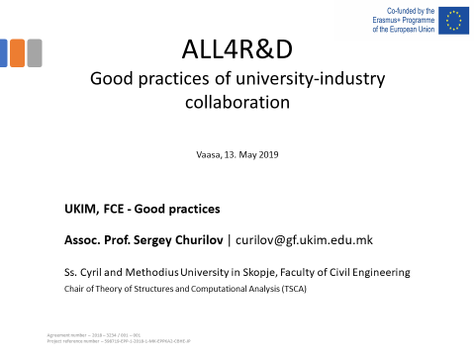

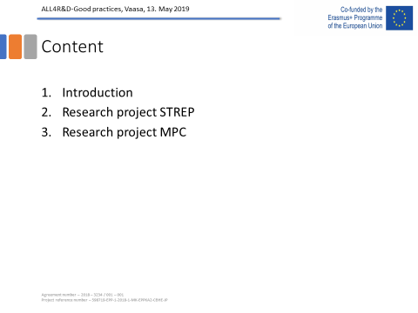
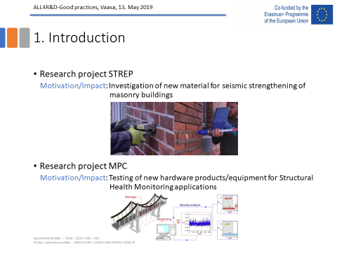
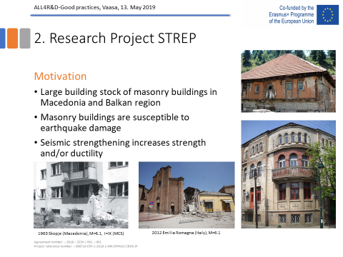
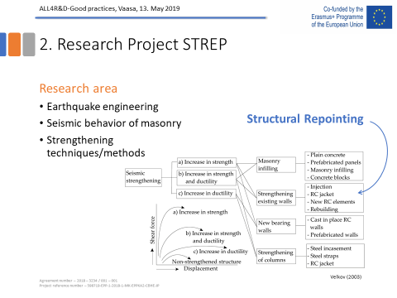
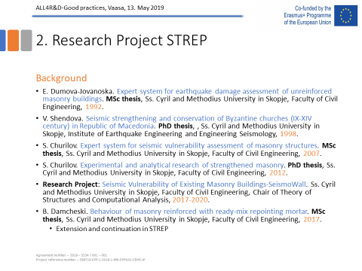
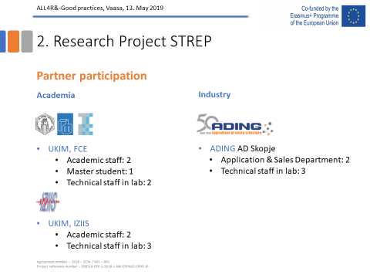
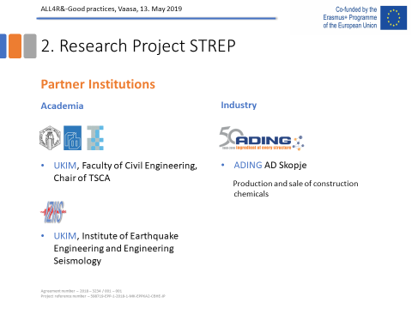
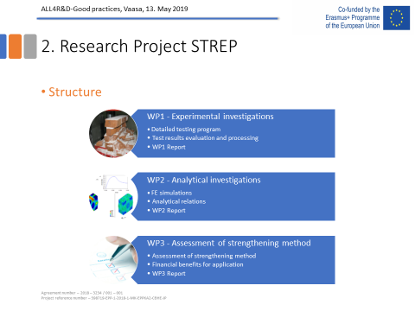
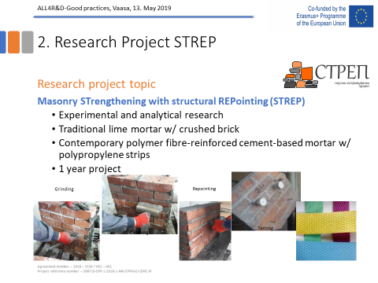
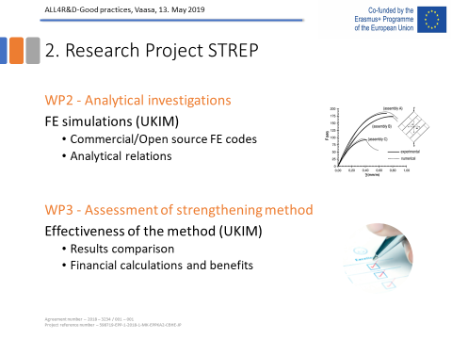
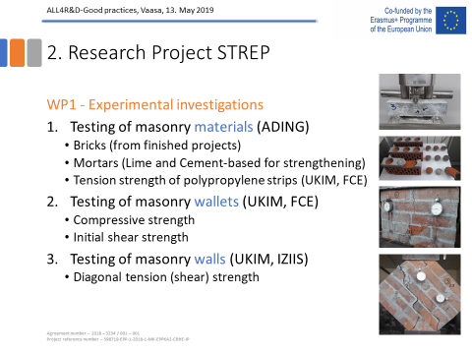
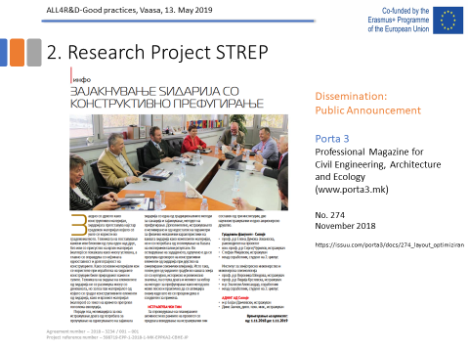
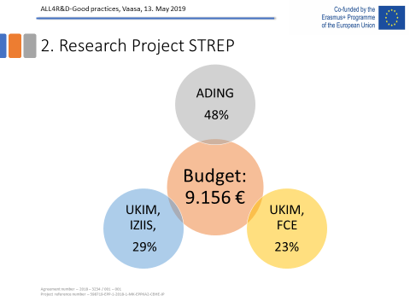
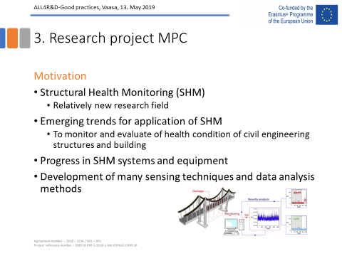
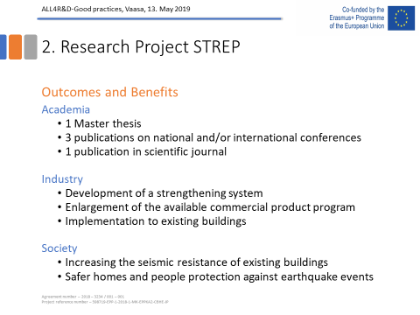
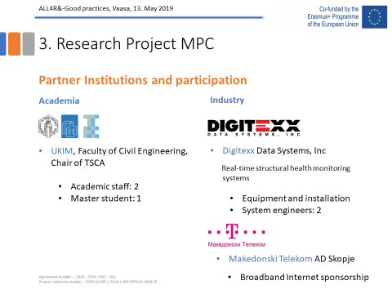
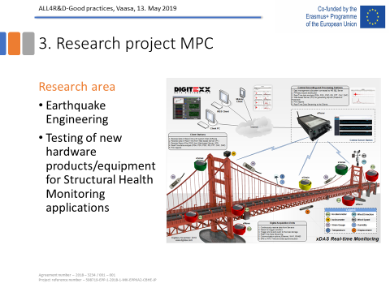
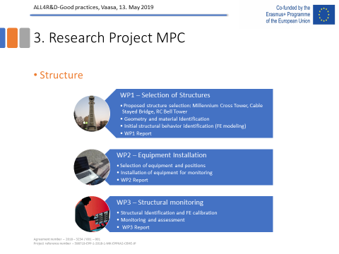
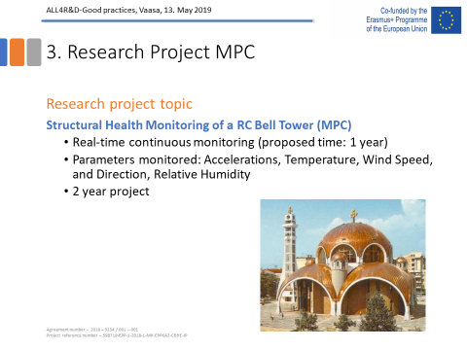
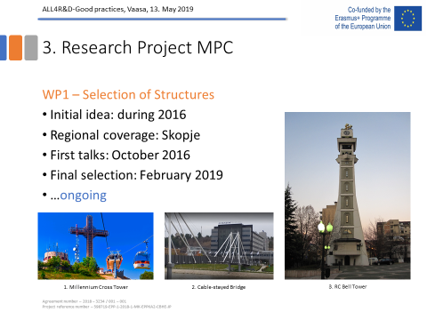
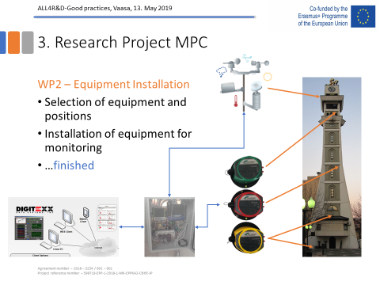
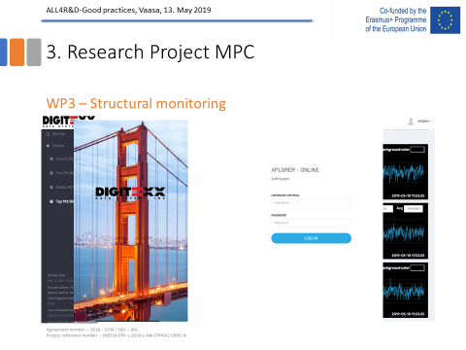
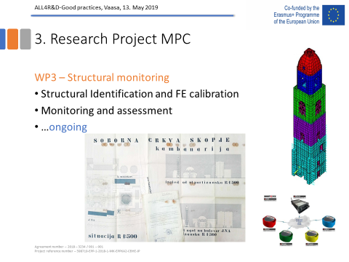
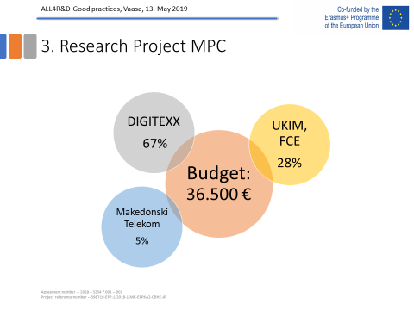
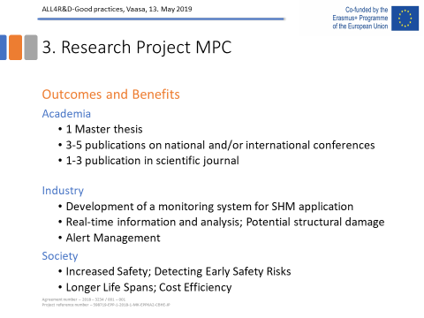
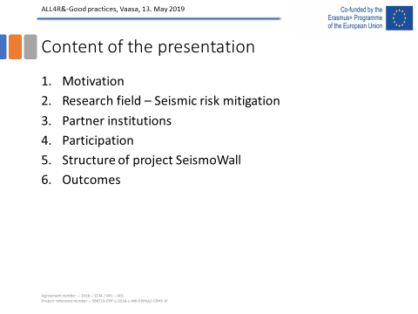
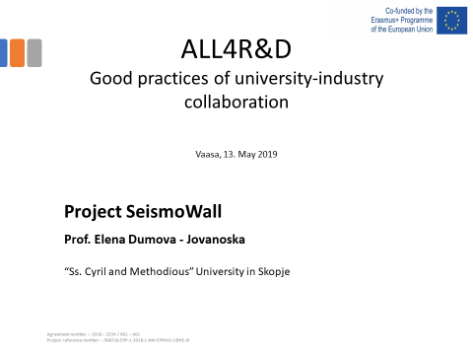
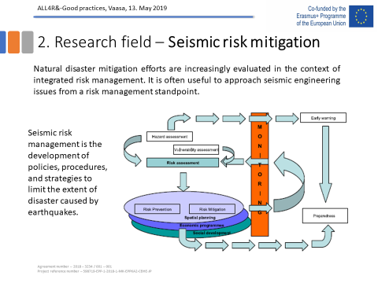
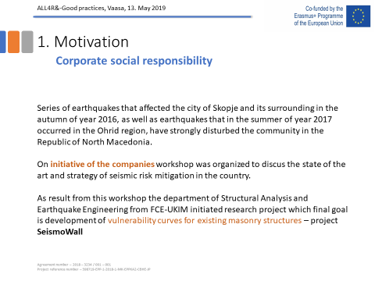
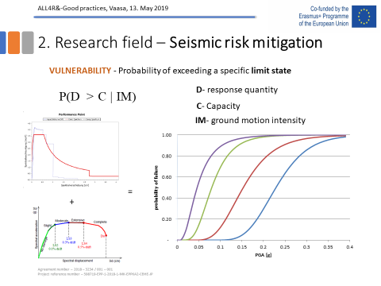
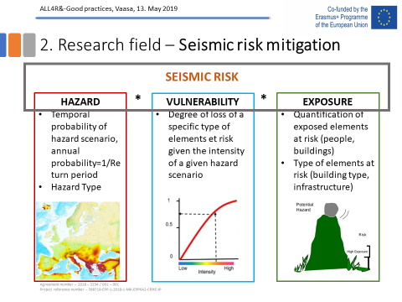
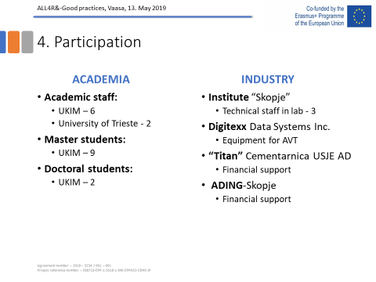
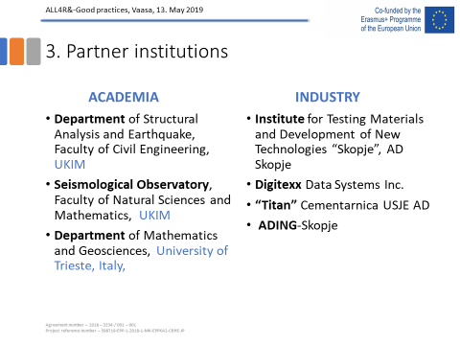
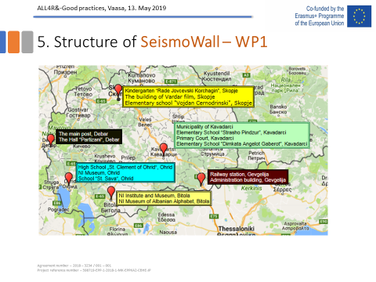
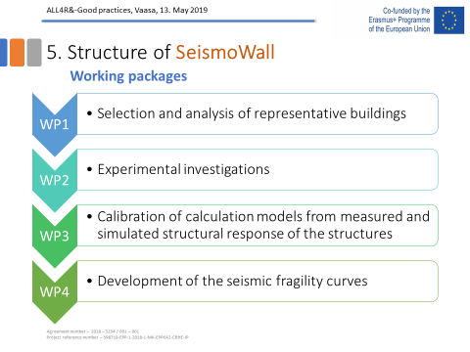
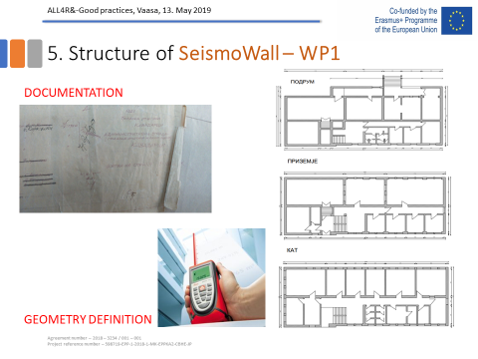
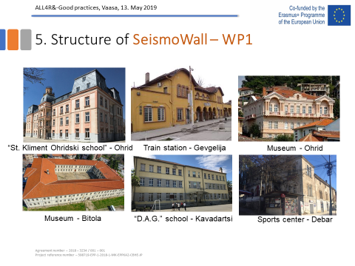
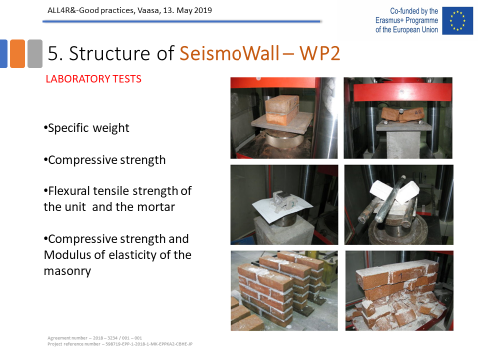
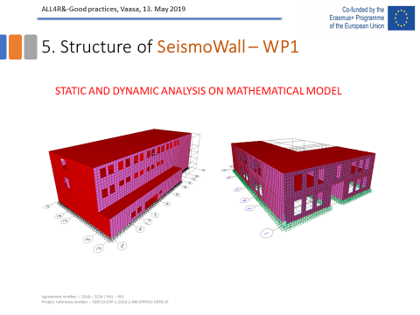
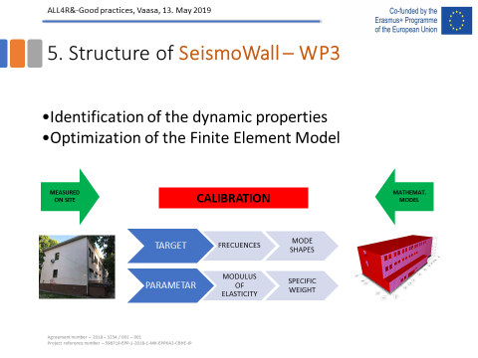
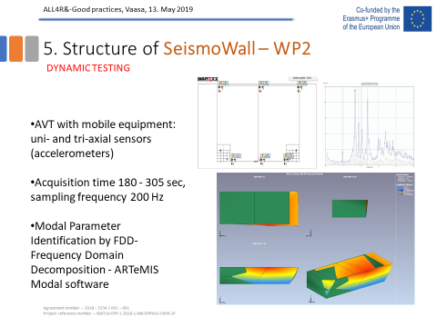
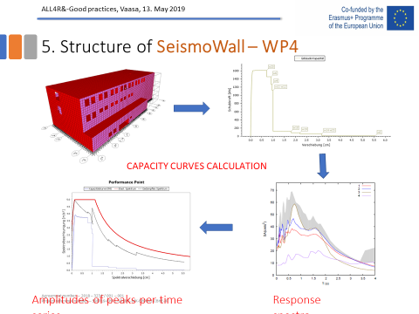
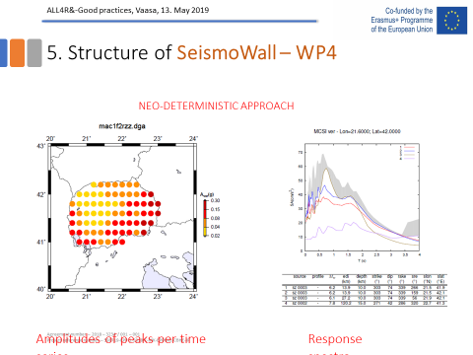
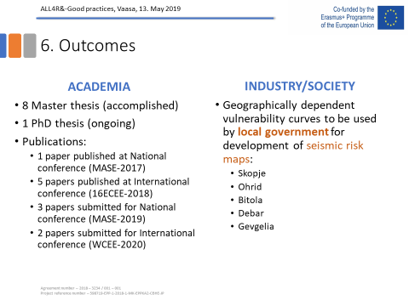
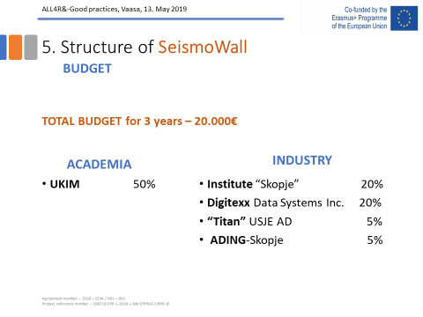
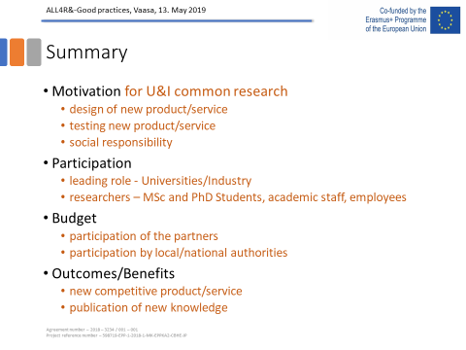

Presentation on good practices IECE
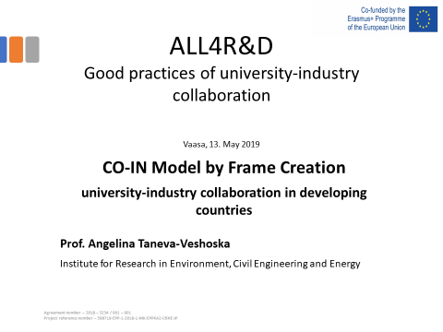
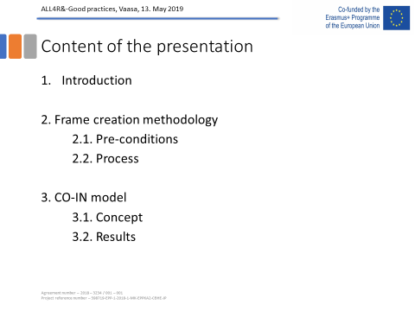
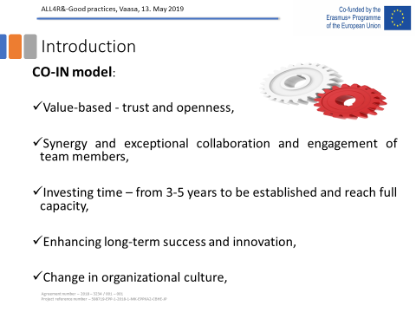
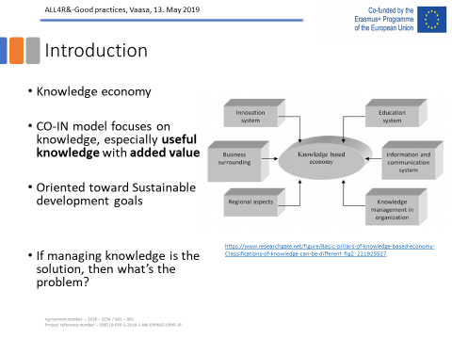
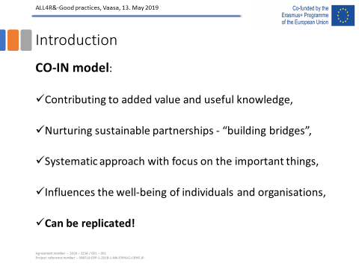
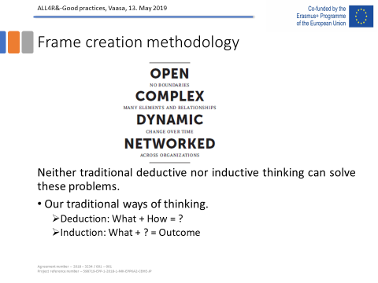
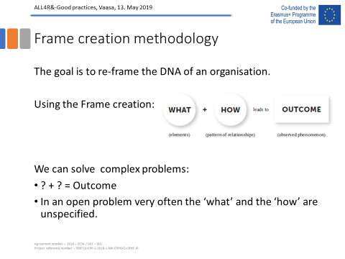
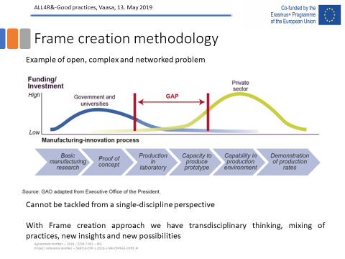
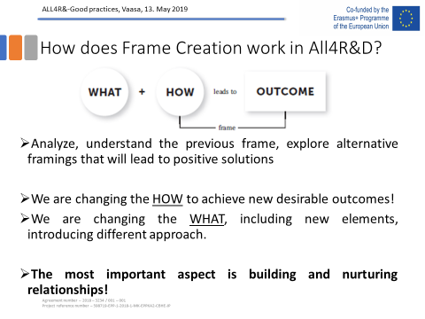
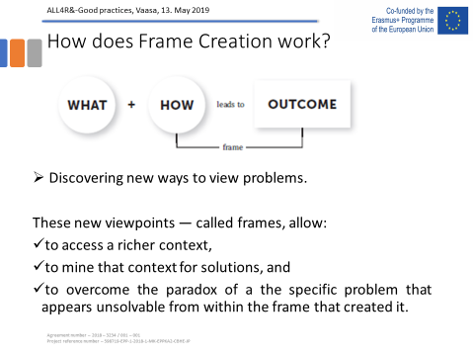
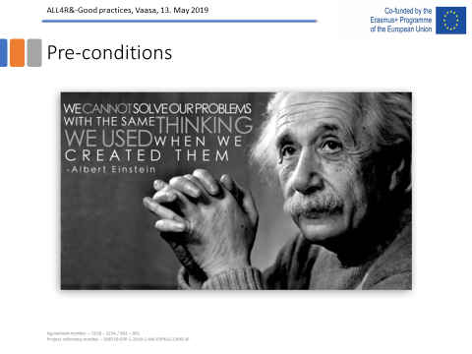
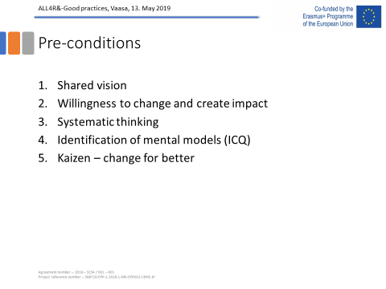
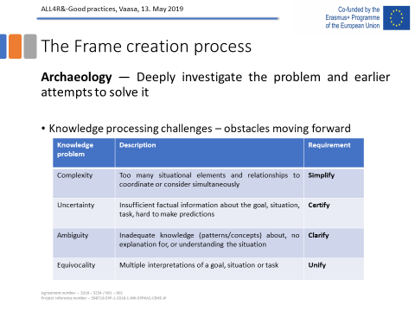
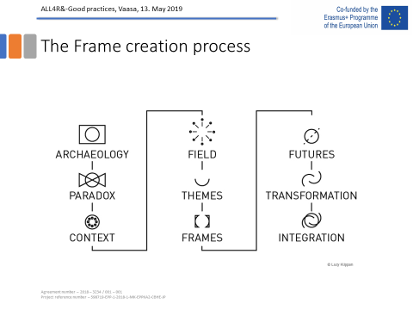
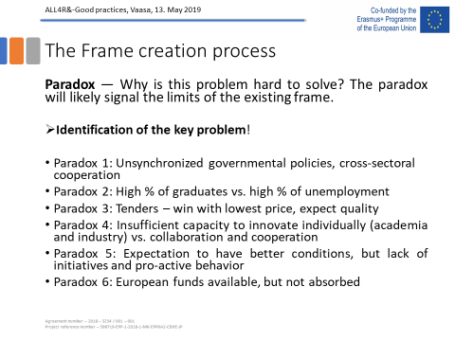
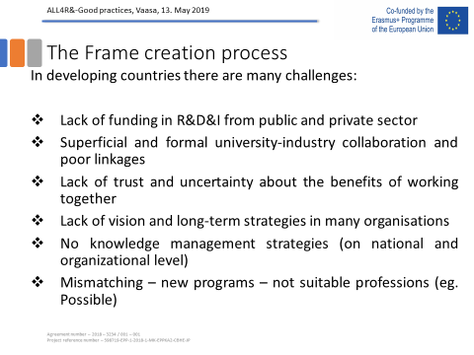
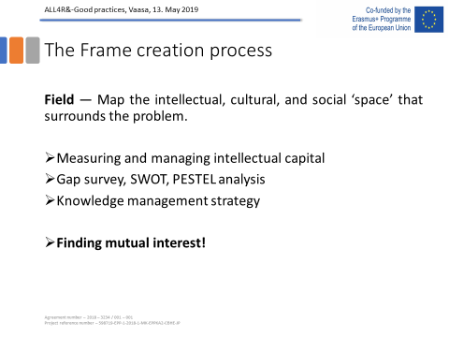
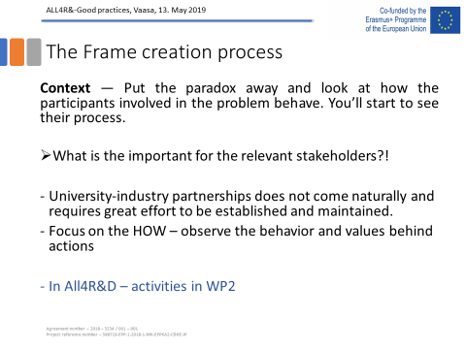
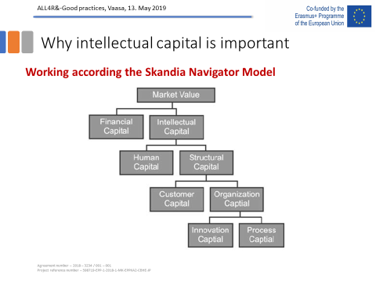
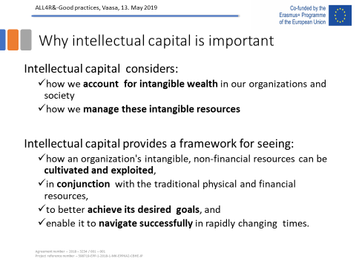
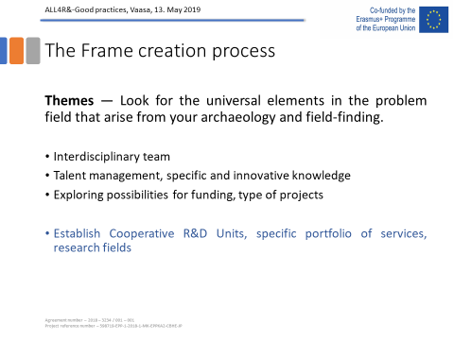
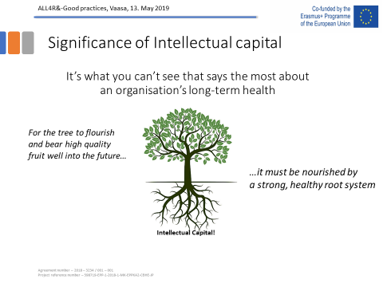
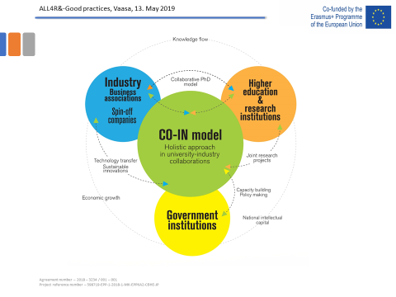
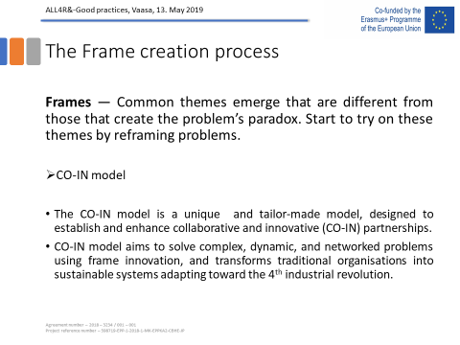
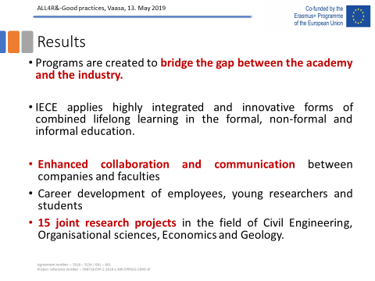
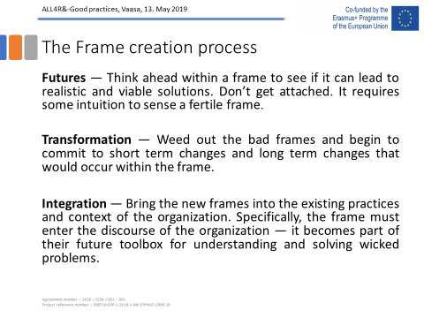
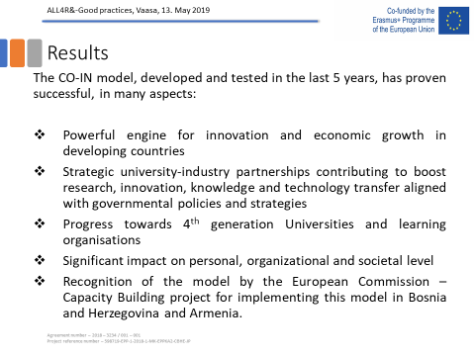

Presentation on good practices RUB
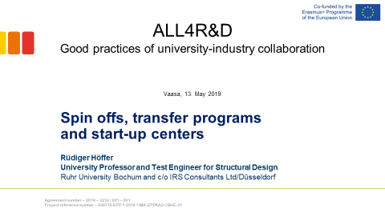
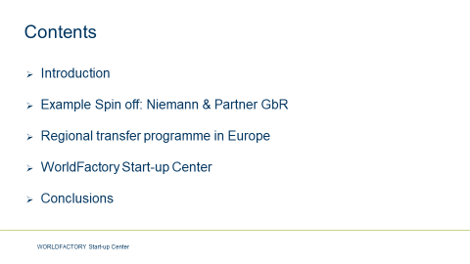

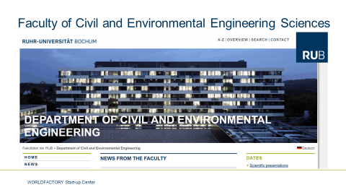
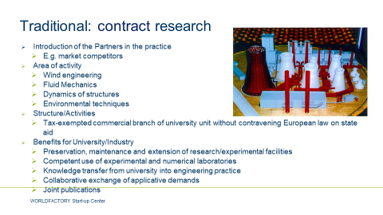

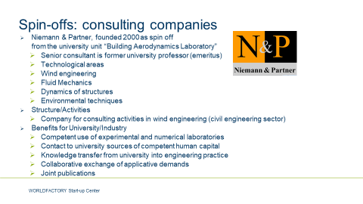
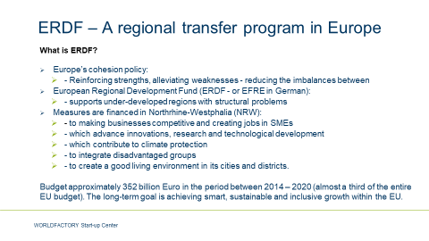
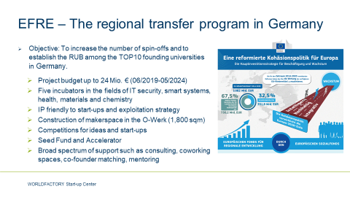

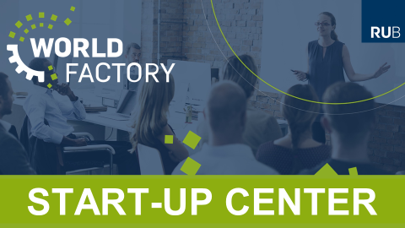

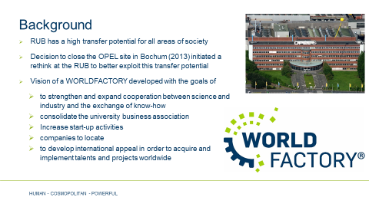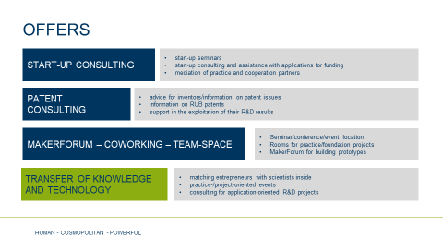

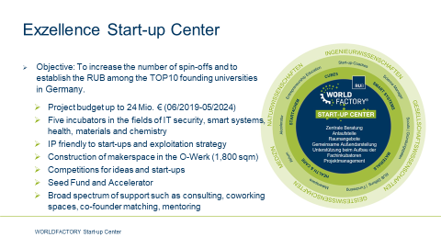

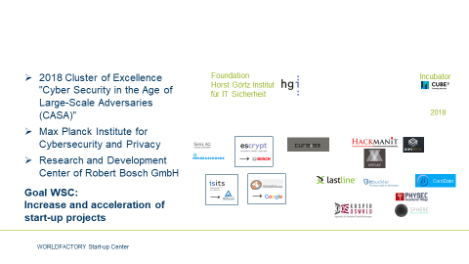

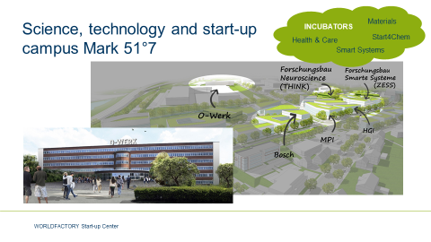
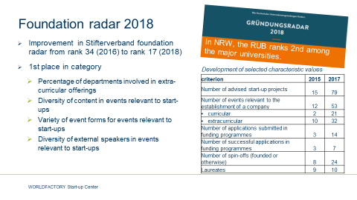

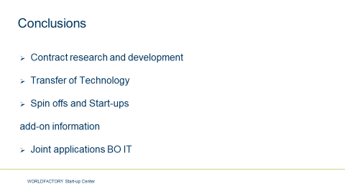

Presentation on good practices UVA

Project ALL4R&D presentation, May 13th, 2019
Prof. Tauno Kekäle, Vaasa University of Applied Sciences

1. Finland and R&D
In light of the latest statistical facts (2017), the Vaasa region that you are visiting is one of only four Finnish regions where R&D spending is greater than the average of the country (average is 3.3 % of the GNP, and the rest 15 regions are below the average). So you are in the right location. Vaasa is actually only number four now, as a region, but it is a very small region too, just 60.000 people in the town Vaasa, a bit over 100.000 in the region. And we do have significant R&D offices of the number two and three most innovation-driven companies in Finland located here, ABB and Wartsila. One of every five inhabitants in Vaasa is a University students; another of every five is an engineer working in Export business.
Altogether, Finland has about 6 million people; a GNP per inhabitant of close to 41.000 euros; and a R&D spending of a bit over 6 billion euros. (The annual State Budget is a bit over 55 billion, year 2019).
Number one region in R&D should naturally be Helsinki, the Capital, greater Helsinki with a million inhabitants and especially neighbouring Espoo with lots of software companies and the headquarters of the biggest energy - Fortum Ltd - and oil - Neste - companies, as well as Aalto University, the biggest tech university in Finland. But actually they are only number three. R&D spending in that region is about 2 billion euro (2016 numbers) but it's just 4.2 % of that region's GNP. (I use the R&D to GNP percentages as a way of ranking very different-size regions for innovation).
Number one, instead, is the Oulu region, which is located far north also by our standards (200 miles north from here, 500 from Helsinki). They are about 200.000 people in the city but have an R&D spending of 500 million euros, which is 6.3 % of the region's GNP. This has traditionally been the hotbed of Nokia and its suppliers' product development, but also a region known of very tight industry-university cooperation. A university of Oulu- based innovator, Polar Electro, might arguably be the origin of wrist-held health & communication devices of today, such as the Apple Watch.
Also before Helsinki on the list comes the heavy-industry capital of Finland, Tampere; about 250.000 people in town, their R&D spending is 450.000 euros which is about 4.4 % of their GNP. Some of their heavy industries still have survived the digitalization (e g mining equipment from Metso and Sandvik) and a lot of the R&D spending in Tampere goes towards automatization and AI.

These orientations are very similar to those found in Vaasa. Our industry is very much concentrated around energy generation and transfer; main company Wartsila produces big diesels for power stations and shipbuilding, the second biggest company ABB makes special transformers, wind power generators, electric motors and hrid protection relays. Our about 100.000 people spend 175 million euro or 3,5 % of our GNP in R&D, and we are number four on the percentage list. Our universities are also very small, so this is to 75-80 % direct company spending. (Overall in Finland, of the total spending in R&D of about 6 billion, companies spend about two thirds, government and universities about one third.)
A curiosity worth mentioning here might be that the wealth of both Oulu and Vaasa regions originally stems from building wooden sailing ships; Oulu especially for tar and woodwork production, Vaasa first for the ships, then for engines. Just 50 miles north of Vaasa, two of the most important sailing yacht companies in the world, ultra-luxury Baltic Yachts and competition-oriented yacht company Nautor (with brand name Swan) still prosper. And Wartsila Ship Diesels of course.
Shipbuilding in Finland is indeed a tradition, but, as with everything in Finland, a heavily taxed country with free PhD studies to everybody, we keep on specializing. The biggest stuff here nowadays are the most luxurious of ocean-class cruise ships (at the Turku shipyards, recently bought up by German family company Meyer Werft) and, at nearby Rauma RMC Yards, especially arctic icebreakers, car ferries and floating islands (!!). In shipbuilding, the most innovation activities are today geared towards energy savings, pollution reduction, and self-navigating vessels. Main players there, except the shipyards mentioned, are Rolls-Royce, our Wartsila, and the universities Aalto (located in Espoo) and Turku university research - both Univ of Turku and Turku University of Appled Science. Turku is also big in biotech and medicine and number five of the R&D regions, a bit over 250.000 people, and with 3.2 % of GNP in R&D spending very close to the country average.
2. Some Finnish innovations from the history
And what about the Finnish innovations? Our only industry nobel prize this far went to A I Virtanen for his method of chemically conserving hay over several years, to be used as "ever-fresh" animal feed. That was important and ground-breaking then (1945), less so now - even if still in use. Also shos that in 1945 – and also in 1955 – Finland stilöl was mostly an agricultural country.
The Nordic Mobile Phone network gave birth to GSM telephony, on which today's mobile phone networks are largely based, and of course Nokia; and these again to some related innovations such as Short Messaging System SMS. Also open software has had some Finnish innovators, most notably Linux OS (Linus Thorvalds, son of a Finnish EU MP Nils T., from Helsinki) and MySQL (of Vaasa-born Michael Widenius, named after his daughter My :-) ).
A lot of the modern paper-producing technology is developed in Finland, and we are still one of the bigger paper producers of the world (around 8 %, with a population share of around 0,75 %). We are also a big seller of paper machines (Metso). A lot of Finnish products, such as these, are unfortunstely investment-grade and thus not too known to consumers. One also might be tempted to check the production VIN badge of one's Porsche Boxster; it might be Made in Finland (most of them are).
Yet one Finnish product that might be big enough to be known by the brand name anywhere is the Xylitol birch sugar. This, along with cholesterol-reducing margarines and cheeses, are examples of health-heavy Finnish University sector (Universities of Helsinki, Turku, Kuopio, and Oulu) innovation, flowing into industrial products.
For a partly tongue-in-cheek listing, for Finnish innovations over the years, see http://en.biginfinland.com/inventions-finnish/ - it starts off with the Molotov Coctail....

3. The Finnish Higher Education system
At the demise of the Soviet Union in late 1980s, the market for Finnish manual work products (clothing, shoes, furniture etc) fell dramatically, This led to nationwide rise of unemployment to about 19 % in 1993. To counter this huge problem in the longer run, the government decided that raising the education level of the population would be required. The method selected for this was to double the higher education sector, on the side of the traditional universities, along the model of the German “Fachhochschulen”, the Universities of Applied Sciences.
The two Higher Education sectors are meant to take care of clearly different tasks. The “traditional Universities’” Law states the Universities “shall conduct scientific research, and give highest tuition based on said research”. The Universities of Applied Sciences (UAS) shall, according to the UAS Law, “develop skill and knowledge to the work-life of their region, and help develop the region”. Because of the “applied science”, the Universities of Applied Science are not supposed to conduct basic research, and, thus, also not to give doctoral degrees, even if they are clearly more teaching-oriented of the two sectors. Furthermore, due to the “working-life skills” requirement, the UAS four-year Bachelor studies include obligatory one-year work-life practice, while the “traditional universities” Bachelor studies are just three years. Also, there is an obligatory work-life experience of two years required between the UAS’ bachelor and Master Degrees. The UAS Masters remind quite a lot of the traditional Universities’ MBA studies in that the final thesis should develop a specific work-place process rather than be purely scientific.
The PUBLIC R&D funding of about 2 Billion (of a total of 6 Billion) also reflects the different tasks of the university sectors. The 23 Universities’ of Applied Sciences’ total R&D spending (about 100 million) is very close to that of the second biggest (Allto University of Espoo, at 90 million) of the 13 traditional Universities alone. The biggest, University in Helsinki, has a R&D budget of 140 million. The Universities of Applied Sciences are, due to their regional ownership and region development responsibility, mostly selling their services directly to the company/private sector, and the projects are also relatively small (e g testing of a prototype). The Traditional Universities with their basic research responsibility are the recipients of most of the EU research funding, of basically all of the Finnish Academy of Science funding (oriented solely towards basic research) and of more than half of the Business Finland (formerly TEKES, National Technology Development Center) funding. The latter is oriented towards cooperation of companies and universities, but the allowances have crashed more than 50 % in recent years. Thus, publicly funded University & industry co-research funding (all the three above, in total) was only about 500 million Euros in 2017 statistics (60 millions additionally allowed for 2019). Universities themselves do their own basic and Doctoral research with an input of 1.500 million Euros annually from their general budgets (2017), and, as noted, of this sum of 1.500 million, the Universities of Applied Sciences’ total proportion is less than 100 million.
It is fairly correct to say that the Traditional Universities’ R&D funding comes from their basic funding budget, the Academy of Finland, TEKES, and the EU international funds (e g Frame Programmes) while the Universities of Applied Sciences’ funding is mainly from regional developent funds (e g ERDF, Bothnia Atlantica), the companies, and the owning municipalities. Also, the time frame of the research projects of the Traditional Universities is typically of several years, while the UAS do mostly applied research projects of less than one year with the companies. This is not legally bound to be so; it is more a function of the different approaches to R&D and the connection to local industries’ needs.
4. Answers to your specific questions
a) How do the UAS market their testing & development services to the regional companies?
We at Vaasa UAS have one person who annually tours the major companies that would seem to be in need of product design help. This is taken care of by our Design unit MUOVA. For the technical testing services of Technobothnia, we have an agreement with the local Technology Transfer office Merinova Ltd to market them among new customers. However, the biggest R&D sales come through long-term, everyday contacts with the major companies. To systematize this, we have signed cooperation agreements with the 18 major employer businesses in the region, plus the Town of Vaasa social work office and the Central District Hospital of Vaasa. These employers reflect the main orientation of the Bachelor and Master programs of Vaasa UAS (or, rather, vice versa, our curriula is based on interviews of their needs about every five years). The signed cooperation agreements, firstly, state the contact persons of both Vaasa UAS and the company, in the main fields of cooperation. Secondly, we state the ways how the company participates in our educational programs and their visibility (employer reputation building) at our Campus. Finally, there’s an annual evaluation meeting between the management of Vaasa UAS and the company in question. In brief, then, the sales of our services to the main businesses of the region are thought to succeed through maximum visibility of the UAS and the tight connects/ease of making contact to the right persons.
b) Is this cooperation somehow connected to the salaries of the teachers?
The Finnish salary systems are extremely social-democratic; nearly everybody’s salery is equal (and relatively high). There are some possibilities to gain higher salary for increased responsibility, but very marginal possibilities (clearly less than 10 %) to pay for cooperation performance. On the other hand, the state finance from the Ministry of Education and Research is in Finland based 100 % on the results of the University; we get NOTHING if the students do not graduate, if they do not get a job within 12 months, if we do not get external (PUBLIC) research funding, and if we do not publish. Thus, there is indeed an incentive for the teachers to do their best for the industry cooperation (which improves ALL the major finacing criteria): they get to keep their jobs.
c) What about the regionally-funded professorships?
The professorships that are funded for e g five years by the regional funds (municipalities, businesses e g ) are indeed a good way to make sure the cooperation between these companies and the research conducted by the professor is based on mutual interests. However, given that the public funding from the Ministry is nearly 100 % based on results, it would also be very difficult to quickly start up a new field of research without this kind of “seed funding”. If there over time is a broader interest towards this new field of regionally-funded research, it is typically continued after the first 5-year period by the participating university from their own funds.

TK 14.5.2019

A = Author; E = Editor; C = Contributor; REV = Reviewer; EXT = External Reviewer
https://data.worldbank.org/indicator/ny.gdp.pcap.cd
https://www.globalinnovationindex.org/Home
https://www.globalinnovationindex.org/analysis-indicator
http://uis.unesco.org/apps/visualisations/research-and-development-spending/
Hampson, K., Kraatz, J.A. and Sanchez, A.X., 2014. The global construction industry and R&D. In R&D Investment and Impact in the Global Construction Industry (pp. 42-61). Routledge.
http://dpiproceedings.com/index.php/dtetr/article/view/13396
https://cdn3.euraxess.org/sites/default/files/policy_library/bosniaherzegovina_countryfile_2012_final.pdf
The Questionnaire on Intellectual capital is in Annex
https://www.meyerturku.fi/en/meyerturku_com/media/news_releases/news_releases.jsp

