Guideline for Portfolio and Services

Promoting academia-industry alliances for R&D through
collaborative and open innovation platform

Project reference number: 598719-EPP-1-2018-1-MK-EPPKA2-CBHE-JP

Project duration: 15 November 2018 – 14 November 2021
EU funding instrument: European Neighbourhood Instrument (Erasmus+: KA2 CBHE)
Erasmus+ (CBHE) grant amount: 531,165.00 €
Partner countries: Armenia, Bosnia and Herzegovina, North Macedonian, Austria, Germany, Finland
Target groups: University management and students, companies, research institutions, intermediaries.
Grant holder: Ss. Cyril and Methodius University in Skopje, North Macedonia
Coordinator: Prof. Elena Dumova-Jovanoska, Ss. Cyril and Methodius University in Skopje

This project has been funded with support from the European Commission. This document reflects the views only of the author, and the Commission cannot be held responsible for any use which may be made of the information contained therein.
This document is licensed under Creative Common
Attribution-NonCommercial-ShareAlike 4.0 International.

Document information
Workpackage | WP2 – Capacity building of Cooperative R&D Units
Workpackage leader | UKIM and IECE
Due date | July 19, 2019
Revision | Version 1.0
Authors | Slavica Trajkovska, Ana Tomikj
Contributors

Version | Name, Partner | Status | Date | Summary of changes
1.0 | IECE | First version | 05.07.2019
DELIVERABLE REVIEW HISTORY

Disclaimer
This project has been funded with support from the European Commission. This deliverable reflects the views only of the author, and the Commission cannot be held responsible for any use which may be made of the information contained therein.

Contents
Services 4
Portfolio of Services 5
Service and goal roadmap 5
Service Blueprint 6

This Document serves as a Guideline to create and produce portfolio of service for each of the Cooperative R&D Unit. The following templates and questions will support the process of defining the services and it can be adopted accordingly to the nature of each Cooperative R&D Unit.

Services

- Describe your current and near-future services?

- What gives your services clear competitive advantage?

- What are the benefits and value provided to customer as opposed to 'features'?

- What are the environmental and social impacts and implications?

- What regulations, standards and codes must be complied with?

Also consider conducting analysis and planning for this section across the following stages:
Current Situation

Key Service and Market Issues

Fields of operation (Science and education topics)

Key Strategies

Performance Measures and Targets

Portfolio of Services

Name of services | Type of services | Price
Service 1 | Education | -
Service 2 | Research | -
Service 3 | Consultancy | -
Service 4 | Education | -
Service 5 | Research | -
Service 6 | Consultancy | -
Service 7 | Education | -
Service 8 | Research | -
Service 9 | Consultancy | -
Service 10 | Education | -
Service 11 | Research | -
Service 12 | Consultancy | -
Service 13 | Education | -
Service 14 | Research | -
Service 15 | Consultancy | -

Service and goal roadmap

SERVICE AND GOAL ROADMAP
Service name | Release | Q1 | Q2 | Q3 | Q4
 |  | Goal name | Goal name | Goal name | Goal name
Service 1 | dd.mm.yyyy | Goal 1
Service 2 | dd.mm.yyyy |  | Goal 2
Service 3 | dd.mm.yyyy |  |  | Goal 2
Service 4 | dd.mm.yyyy |  |  |  | Goal 3
Service 5 | dd.mm.yyyy |  |  |  | Goal 3
Service 6 | dd.mm.yyyy |  | Goal 1
Service 7 | dd.mm.yyyy | Goal 1
Service 8 | dd.mm.yyyy | Goal 1
Service 9 | dd.mm.yyyy |  | Goal 2
Service 10 | dd.mm.yyyy |  |  | Goal 2

Service Blueprint

A service blueprint is a diagram that visualizes the relationships between different service components — people, props (physical or digital evidence), and processes — that are directly tied to touchpoints in a specific customer journey.
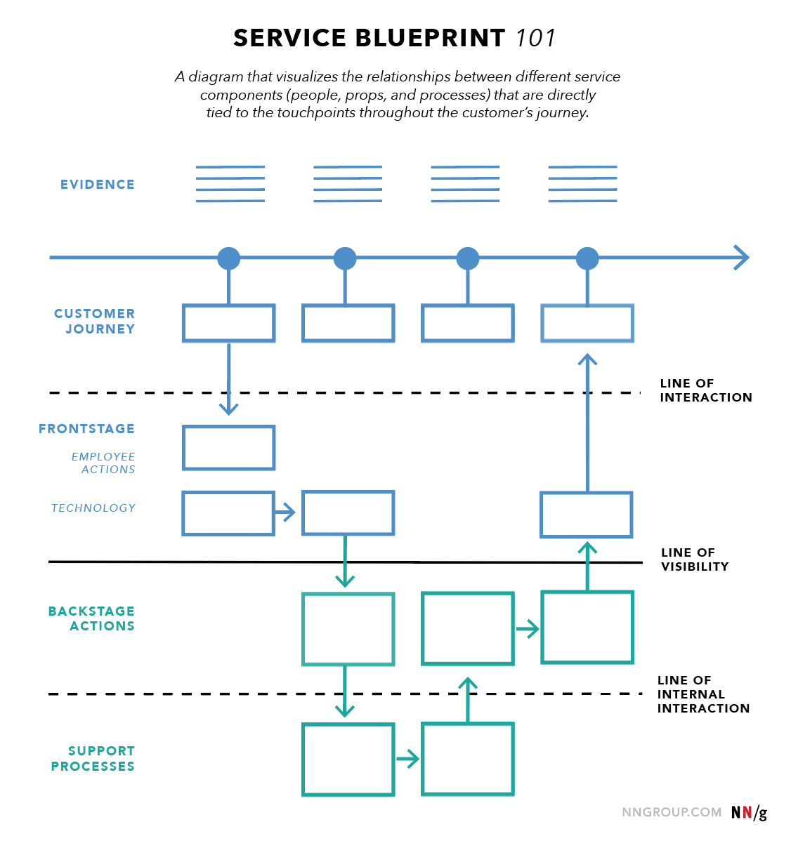
Source: https://www.nngroup.com/articles/service-blueprints-definition/

A = Author; E = Editor; C = Contributor; REV = Reviewer; EXT = External Reviewer

